Chapter 7: User and System Interfaces
User Interface
Experienced developers recognize the importance of all aspects of the user interface and recommend using several techniques that place the user at the centre of the development process. These techniques are referred to collectively as user-centred design. User-centred design techniques emphasize three principles:
- Focus early on users and their work: User-oriented analysis and design tasks are performed as early as possible and are often given higher priority than other tasks.
- Evaluate designs to ensure usability: The goal of user-centre design is usability, the degree to which a system is easy to learn and use. Ease of learning and ease of use sometimes conflict. For example, a system can be easy to learn but be cumbersome to use all day. Usability is not always easy to achieve.
- Use iterative development: doing some analysis, then some design, then some implementation, and then repeating the processes. After each iteration, the project team evaluates the work on the system to date. Iterative development keeps the focus on the user by continually returning to the user requirements during each iteration and by evaluating the system after each iteration.
Note: Agile methods typically use a spiral model, which represents a series of iterations, or versions, based on USER feedback. See page 212
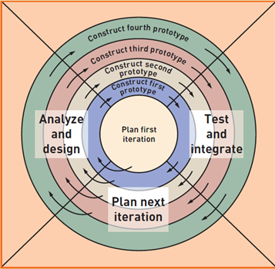
Human-computer interaction (HCI) – field of study concerned with the efficiency and effectiveness of user interfaces to computer systems, human-oriented input and output technology, and psychological aspects of user interfaces
Metaphors, analogies between features of the user interface and aspects of physical reality that users are familiar with, assists analysts to define and describe the user interface more effectively. Such metaphors as
- direct manipulation metaphor: metaphor in which objects on a display are manipulated to look like physical objects (pictures) or graphic symbols that represent them (icons)
- desktop metaphor – metaphor in which the visual display is organized into distinct regions, with a large empty workspace in the middle and a collection of tool icons around the perimeter
- document metaphor – metaphor in which data is visually represented as paper pages or forms. Browsing and entering data on electronic documents, like hypertext and hypermedia approaches are based on the document metaphor
- dialog metaphor – metaphor in which user and computer accomplish a task by engaging in a conversation or dialog via text, voice, or tools such as labeled buttons. The user asks the computer for something, and the computer responds. The computer might then ask the user for something, and the user responds.
All the above describe the user interface in slightly different terms and help in understanding and specifying an effective user interface.
It is important in the detailed design of the user interface to consider good design principles. Such design principles as visibility, affordance, user shortcuts, feedback, closure, error messages, and reversal of actions are all important no matter what type of user interface is being designed. The judicial use of menus and navigation techniques also make the user interface more usable. Often the best way to organize menu items is to group menu items together by actor or user role.
A powerful technique in the design of the user interface is to use storyboards. Storyboards are nothing more than a set of layouts that mimic the sequence of steps for a particular use case or user process.

Affordance and Visibility
There are two key principles that ensure good interaction between a person and a machine: visibility and affordance.
Visibility means that a control should be visible so users know it is available, and that the control should provide immediate feedback to indicate it is responding.
Affordance means that the appearance of the control should suggest its functionality—that is, the purpose for which the control is used.

Consistency
A consistent-appearing and consistent-functioning interface makes the system easy to learn and use. The way information is arranged on forms, the names and arrangement of menu items, the size and shape of icons, and the sequence followed to carry out tasks should be consistent throughout.

Shortcuts
User interfaces and dialogs designed for novices are often an annoyance and impediment to experienced users’ productivity. Users who work with an application repeatedly or for long time periods want shortcuts for frequently used functions

Feedback
Every action a user takes should result in some type of feedback from the computer so the user knows the action was recognized. Feedback provides the user with a sense of confirmation and the feeling that a system is responsive and functioning correctly.
Dialogs That Yield Closure
Any well-defined task has a beginning, middle, and end, so users’ tasks on the computer should also feel this way. The user can get lost if it is not clear when a task starts and ends.

Error Handling
A good user interface design anticipates common errors and helps the user to avoid them. When errors do occur, the user interface needs mechanisms to detect then. When the system does find an error, the error message should state specifically what is wrong and explain how to correct it.

Easy Reversal of Actions
Users need to feel that they can explore options and take actions that can be canceled or reversed without difficulty. This is one way that users learn about the system—that is, by experimenting.

Reducing Short-Term Memory Load
People have many limitations, and short-term memory is one of the biggest. User-interface designers should avoid requiring the user to remember anything from one form to another or from one dialog box to another during an interaction with the system.

The Transition from Analysis to User-Interface Design
Use cases that require direct user interaction (i.e., interactive use cases) are the starting point for a dialog, and the corresponding use case, activity, and system sequence diagrams are the initial dialog documentation.
Dialog and user-interface design can proceed in either a top-down or bottom-up fashion. In the top-down approach, menus (groups of related use cases, dialogs, and user interfaces) are defined first, followed by a detailed description of each interactive use case dialog and development. In the bottom-up approach, interactive use cases are prioritized, and related dialogs and user interfaces are developed one at a time followed by the menus that tie all the user interface components all together.

Use Cases and the Menu Hierarchy
Menus are a way of grouping large numbers of related use cases or dialogs within a user interface. In all but the smallest systems, menus are needed to present the user with a tractable number of choices per screen, to group related functions together so users can more easily locate them.
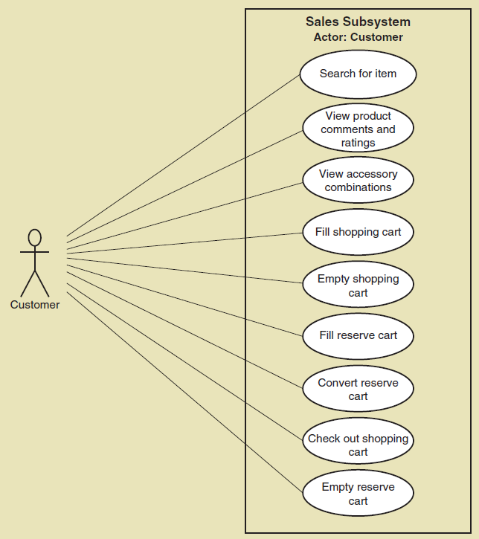

An initial grouping of these cases by actor and subsystem is a good starting point for menu design:

Dialogs and Storyboards
After identifying all required dialogs, the designers must document the dialogs. One approach is to list the key steps followed for the dialog with a written description of what the user and computer do at each step. Designers can also document dialog designs by writing out how the user and system might interact if they were two people engaged in conversation.
There are many possible implementations of a dialog scenario. Before deciding on a specific implementation, an analyst often uses a technique called storyboarding.

User-Interface Design

Key Terms
- text box – a rectangular box that accepts text typed on a keyboard or recognized from speech input
- list box – a text box that contains a list of predefined data values
- combo box – a text box that contains a predefined list of acceptable entries but permits the user to enter a new value when the list doesn’t contain the desired value
- radio buttons – a group of choices from which the user selects only one; the system then automatically turns off all other buttons in the group
- check boxes – similar to radio buttons, but the user can select multiple items within the group
- cascading style sheets (CSS) – Web page encoding standard that enables a Web site designer to specify parts of a page that will always look the same and parts that will vary by task or audience
- assistive technologies – software (such as text-to-speech and voice-recognition utilities) that adapts user interfaces to the special needs of persons with disabilities

Notes
As computing devices have proliferated, available devices and technologies for user interfaces have grown more powerful and diverse. Displays range from large-format, flat-panel monitors used with desktop computers to much smaller displays on tablets and cell phones. As the range of user-interface technologies has increased, so has the need to create multiple user interfaces.

Guidelines for Designing Windows and Forms
Interface Layout and Formatting: High-quality interfaces are well laid out, with the fields easily identified and understood. As you design your interfaces, you should think about these:
- Consistency—All the forms within a system need to have the same look and feel.
- Labels and headings—Labels should also be easy to identify and read.
- Distribution and order—Related fields are usually placed next to each other and can be grouped within a box.
- Fonts and colors—Variations in font face and size can help users distinguish different parts of the form, but only a handful of font and size variations should be used for larger screens and as few as possible should be used for small screens.
Data Entry: Several types of data-entry controls are widely used in user interfaces, including Text boxes, List boxes, Combo boxes, Radio buttons, and Check boxes.

Additional Guidelines for Web Browser User Interfaces
Consistency: Consistency is especially critical within Web sites because most sites contain a large number of pages that serve many different purposes and audiences. Cascading style sheets (CSS) are a Web page encoding standard, and they enable a Web site designer to specify parts of the site's pages that will always look the same and parts that will vary by task or audience.
Performance considerations: Performance considerations are also an important issue in Web applications. Web sites in general and browser-based forms in particular are sensitive to application design and to the quality of the network connections between the user’s computing device and the servers that host the site. Designers of Web-based user interfaces must perform a careful balancing act, providing embedded programming code within a page to avoid refreshes but not overloading page content so as to avoid long delays when the user moves from page to page.
Pictures, Video, and Sound: Web-based interfaces are often preferred for their inherent ability to mix text, images, and sound. Powerful and compelling interfaces can be constructed, and they are especially important in customer-facing systems. However, heavy use of sound and images exacerbates the previously discussed performance issues and also creates issues of compatibility. Compatibility issues arise for sound and video because there are so many ways in which they can be encoded. Thus, Web site designers must carefully choose which formats and plug-ins will be used.
Users with Disabilities: Designers of all user interfaces must be sensitive to the special needs of persons with disabilities. Because the Web is such a fundamental resource in the modern world, standards have been developed to ensure maximal usability for those who are visually impaired or have limited dexterity. Providing this kind of support is part of the class of software called assistive technologies.

Additional Guidelines for Handheld Devices
Designing Web and app-based user interfaces for handheld devices presents additional design challenges, including:
- Small screen size
- Small keyboards and touch screens
- Limited network capacity
- App design guidelines and toolkits

Identifying System Interfaces

Key Terms
- Extensible Markup Language (XML) – extension of HTML that embeds self-defining data structures within textual messages
- XML tags – character sequences (such as <name> and </name>) that define the beginning, end, and meaning of the text that appears between them
We define system interfaces broadly as any inputs or outputs with minimal or no human intervention such as the following:
- Inputs from and outputs to other systems—These are direct interfaces with other information systems, normally formatted as network messages. Electronic data interchange (EDI) and many Web-based systems are integrated with other systems through direct messaging.
- Highly automated inputs and outputs—These are captured by devices (such as scanners) or generated by persons who start a process that proceeds without further human intervention.
- Inputs and outputs to external databases—These can supply input to or accept output from a system. EDI messages are more commonly used, but direct interaction with another system’s database may be more efficient.
One of the main challenges of EDI is defining the format of the transactions. Modern EDI messages are generally formatted in Extensible Markup Language (XML). XML is an extension of HTML that embeds self-defining data structures within textual messages using XML tags. XML files are in human readable form.

Designing System Inputs
When designing inputs for a system, the system developer must focus on three areas:
- Identifying the devices and mechanisms that will be used to enter input
- Identifying all system inputs and developing a list with the data content of each
- Determining what kinds of controls are necessary for each system input

Automated Input Devices
The primary objective is to enter or update error-free data into the system. Several good practices can help reduce input errors:
- Use electronic devices and automatic entry whenever possible.
- Avoid human involvement as much as possible.
- If the information is available in electronic form, use that instead of reentering the information.
- Validate and correct information at the time and location it is entered.
Here are some of the more common devices used to avoid human keystroking:
- Magnetic card strip readers
- Bar-code readers
- Optical character recognition readers and scanners
- Radio-frequency identification tags
- Touch screens and devices
- Electronic pens and writing surfaces
- Digitizers, such as digital cameras and digital audio devices
- Speech-recognition software

Defining the Details of System Inputs
The fundamental approach that analysts use to identify user and system inputs is to search documents developed during analysis activities for information flows that cross the system boundary. The analyst examines system sequence diagrams to identify the incoming and outgoing messages for each activity or use case, and the design class diagrams to identify and describe the data content.
Figure 7-16 is a partial system sequence diagram for a payroll system. Various use cases have been combined to consolidate the major inputs on a single diagram. The messages that cross the system boundary identify inputs—system inputs and user-interface inputs. There are three inputs defined with message names and input parameters. These three inputs identify user inputs and system inputs.

Designing System Outputs

Key Terms
- detailed reports – reports that contain specific information on business transactions
- summary reports – reports that summarize detail or recap periodic activity
- exception reports – reports that provide details or summary information about transactions or operating results that fall outside a predefined normal range of values
- executive reports – reports used by high level managers to assess overall organizational health and performance
- internal outputs – reports or other outputs produced for use within the organization
- external outputs – reports or other outputs produced for use by people outside the organization
- turnaround documents – external outputs that includes one or more parts intended to be returned with new data or information
- drill down – user-interface design technique that enables a user to select summary information and view supporting detail
The primary purpose of system outputs is to present information in the right place at the right time to the right people. The tasks in this activity focus on four areas:
- Determining the type of each system output
- Making a list of required system outputs based on application design
- Specifying any necessary controls to protect the information provided in the output
- Designing and prototyping the output layout
The purpose of the first two tasks is to evaluate the various alternatives and design the most appropriate approach for each needed output. The third task ensures that the designer evaluates the value of the information to the organization and protects it.

Designing Reports, Statements, and Turnaround Documents
There are four types of output reports commonly provided by an information system:
- Detailed reports—These contain specific information on business transactions.
- Summary reports—These are often used to recap periodic activity.
- Exception reports—These provide details or summary information about transactions or operating results that fall outside of a predefined normal range of values.
- Executive reports—These are used by high-level managers to assess overall organizational health and performance.
Internal versus External Outputs: Printed outputs are classified as either internal outputs or external outputs. Internal outputs are produced for use within the organization. The types of reports just discussed fall under this category. External outputs include statements, notices, and other documents that are produced for people outside the organization. Some external outputs are referred to as turnaround documents because they are sent to a customer but include a tear-off portion that is returned for input later.
Electronic Reports: Organizations use various types of electronic reports, each serving a different purpose and each with its respective strengths and weaknesses. Electronic reports provide great flexibility in the organization and presentation of information. In some instances, screen output is formatted like a printed report but displayed electronically. However, electronic reports can also present information in many other formats.
An important benefit of electronic reporting is that it is dynamic; it can change to meet the specific needs of a user in a particular situation. In fact, many systems provide powerful ad hoc reporting capabilities so users can design their own reports on the fly. One technique, called drill down, allows the user to activate a “hot spot hyperlink” on the report, which tells the system to display a lower-level report that provides more detailed information.
Graphical and Multimedia Presentation: The graphical presentation of data is one of the greatest benefits of the information age. Tools that permit data to be presented in charts and graphs have made information reporting much more user friendly for printed and electronic formats. Information is being used more and more for strategic decision-making as businesspeople examine their data for trends and changes.
Recap:
UI Design
Ease of use
Visualization makes a product click or sink (Xerox, Steve Jobs)
Screen Design
Objects: image, text box, list box, grid, etc.
Addressing: What appears where?
UI Designers: must be creative. MS Visio is a drawing tool and is static.
UI Developers: jsp, asp.net, vb.net. They will create screens
Any application:
Master screens
Transaction screens
Reports
What is the difference among?
- Prototype
- Wireframe
- Forms

Class Exercises:
OPEN MS Visio > Software > Wireframe Diagram
