

FORMATIVE ASSESSMENT 1 – AUGUST 2017

FACULTY OF COMMERCE, ADMINISTRATION AND LAW

DEPARTMENT OF ACCOUNTING AND AUDITING

CMIS302- Information System Management 3C
(Information Systems Design)

DATE: 31 AUGUST 2017 SESSION: 9H30 – 12h30

DURATION: 3 HOURS MARKS: 80

Internal Examiner
Mr. B.F. Nel

Internal Moderator
Mr. I.N. Mthembu

External Moderator
Mr. F. Mudavanhu (Department of Computer Science, UFS)

INSTRUCTION TO CANDIDATES

- Please ascertain that this paper has six (6) pages and three (3) Questions.
- Answer ALL the questions using as applicable, MS Visio, MS Word, MS Project and MS Excel.
- The final answer must be emailed to nelb@unizulu.ac.za.
- Fill in your personal detail on the top of THIS page.
- WARNING!!
Candidates are warned against irregular or dishonest practices, which discredit not only the candidate concerned, but also the good name of the University.
In particular, a candidate is warned against having in his/her possession in the examination room any book, USB, paper or notes not supplied to him/her by the commissioner and NO internet connections.
Penalties must in every case be severe, entailing cancellation of all the candidate’s examinations of the particular year and even disqualification from further enrollment at the University, or any other penalty that the University Council may determine.

Question 1 [20 Marks]
Read the following paragraphs very careful:

Especially for You Jewelers is a small jewelry company in a university town. Over the last couple of years, it has experienced a tremendous increase in its business. However, its financial performance hasn’t kept pace with its growth. The current system, which is partly manual and partly automated, doesn’t track accounts receivables sufficiently, and the company is finding it difficult to determine why the receivables are so high. It runs frequent specials to attract customers, but it has no idea whether these are profitable or if the benefit—if there is one—comes from associated sales. Especially for You wants to increase repeat sales to its existing customers, thus it needs to develop a customer database. It also wants to install a new direct sales and accounting system to help solve these problems.

After some investigation and discussions with especially workers (mainly students employed on a part-time bases), they felt that the system is cumbersome, and time consuming to put through a transaction. To determine if the customer owes/have outstanding balances, is very cumbersome, because it can only be obtained from manual records. This process is time consuming, because there is a shortage of staff.

The students believe that their skills are not the problem. They are youngsters catching quickly up on any technology. Other problems that feature were that there is no system in place to remind/warn customers of their liabilities/outstanding debt. The students work overtime and feel that they could qualify for incentives. The policies are in place to deal with the people who buy on credit, but there is no enforcement. This actually brought to light that although there was no enforcement in place, it is too costly for a small shop like this to run something like that. The students also complain that there is not enough manpower to deal with end of month sales.

- As an analyst trying to understand/make sense of the problem of high account receivables properly, you decided to create an Ishikawa Diagram (or fishbone). Use MS Visio (Business > Cause and Effect) and create this diagram. (11)

Irrespective of the above problems that Especially for You Jewelers experienced, they want to stay current, and provide the student community with exorbitant but affordable jewelry.

Consider the following problem description: Especially for You Jewelers are in touched with many small providers countrywide, but not as efficient as they want it to be. It sometimes happens that their competitors in the nearby city center, have quicker access to latest jewelry. They want their catalogue to reflect the latest update of the supplier’s catalogues. It appears as if the information of the suppliers as they collect it from the web sites, is not up to date.

Especially for You Jewelers selected some students, in corporation with the Marketing Department of the University, to act as ‘agents’, to visit the suppliers for firsthand information.

The agents/rep’s will immediately capture information of specific jewellery, take quality photographs, and send it immediately to the office on campus. The agents must also be able to update the contact details of the suppliers. So management wants a system that assist the agents so that they can communicate more rapidly with the office about the specific supplier and products of interest. This system must be deployed on portable equipment, stand-alone, with Wi-Fi connection or telephone to transmit data and photographs. This will enable Especially for You Jewelers to update their catalogues immediately, even have some advertisements out, and can place orders speedily with the suppliers.

Answer the following questions (b and c) by completing the text boxes:
- Identify at least four Business Benefits of the new system. (4)

- Name at least five System Capabilities. (5)

Question 2 [25 Marks]
The help of the Information System’s department was called for assistance with this project. As the ICT Senior analyst, you have to determine the financial viability of this new Information System project.

The table below shows the expected costs and revenue:
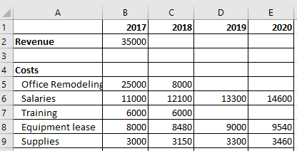
Management believes that the revenue will grow with 10% yearly (effective rate per year).
The initial worksheet to determine analysis for NPV and ROI looks like this:
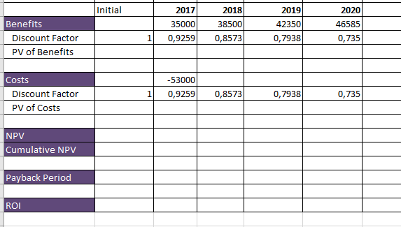

Use the above information and MS Excel and

- Develop a worksheet to determine the NPV over a four year period. The discount factor is calculated at 8% pa compounded yearly: (Show ALL calculations) (15)

- Use the worksheet information and determine the payback period. (3)
The formula for linear interpolation is


- Use the worksheet information and determine the ROI. (2)
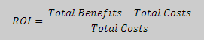

- Draw a scatter chart of year versus cumulative NPV, to give a rough estimate of the payback period, confirming your results in (c). The graph must have a proper title and labels for the axes. (5)

Question 3 [35 Marks]

As an analyst at the above campus, you will lead a training session for new programmers to assist the shop Especially for You Jewelers. You must develop a specific schedule for the following tasks (the estimated duration is shown in parentheses). Although all resources are insourced, senior management wants a detail audit for financial purposes:
- First, you need to contact the participants and explain their roles (1 day). Then you must obtain approval from their department managers (3 days). This task will be performed by your junior analyst (Information System Dept.), paid at R 350-00 p/h. No overtime allowed.
- After you obtain the approval, two tasks can begin at the same time, after task 2 had been competed: you can arrange the meeting room (1 day) and prepare an agenda for the initial session (8 days). The senior secretary (Secretarial Support Group) will assist at a rate of R 200-00 p/h. No overtime allowed.
- When the agenda is ready (task 4), you can start two more concurrent tasks: prepare the information packets (3 days) and create visual aids (6 days). A junior programmer (IT Dept.) will assist at a rate of R 300-00 an hour, and R 350-00 p/h overtime.
- When the meeting room is arranged and the information packets are ready, you can send out an e-mail to participants (1 day).
- Finally, after the e-mail is sent to participants and the visual aids are ready, you can conduct the JAD sessions (7 days). Your rate is R 500-00 an hour. No overtime is allowed.
Tasks
- Prepare a task list or WBS in either MS Word or Excel, showing all tasks and their durations. Headings can be: Task No, Name, duration, predecessor and assigned resource. Analyze the fact situation carefully to determine which tasks are concurrent and which ones depend on other tasks. (12)
- Identify three overview tasks (three main sub-tasks) to the project task, and develop a Gant Chart with resources, using MS project. The project must start on the 11th September 2017. (13)
- Did you encounter any problems, like meeting the ROG: Red Over-allocation Guy?
Or the Burning man?
What steps did you take to solve this problem? (4)

- Create a milestone, and explain its significance. (2)

- What is the total duration and cost of the project? (2)
Duration:

Cost:

- What is the critical path for this project? (1)

- What is meant by the term ‘critical path’? (1)

Total: 80 Marks

************************************ End of Paper ***************************

