

FORMATIVE ASSESSMENT – SEPTEMBER 2018

FACULTY OF COMMERCE, ADMINISTRATION AND LAW
RICHARDS BAY CAMPUS

DEPARTMENT OF BUSINESS MANAGEMENT

CCIS102-Management Information Systems 1.1

DATE: Friday 28 September 2018 SESSION: 11h30 – 12h30

DURATION: 1 HOUR MARKS: 75

Internal Examiner
Mr B.F. Nel

Internal Moderator
Mr N.I. Mthembu

INSTRUCTIONS TO CANDIDATES

- Please ascertain that this paper has 4 pages and 20 questions.
- Answer ALL questions:
  - Questions are answered using MS Word
- Fill in your personal detail:
  - On top of THIS page.
  - DO it NOW!
- WARNING:
Candidates are warned against irregular or dishonest practices, which discredit not only the candidate concerned, but also the good name of the University.
In particular, a candidate is warned against having in his/her possession in the examination room any book, USB, paper or notes not supplied to him/her by the commissioner. ONLY MS Word must be open at any time.
Penalties must in every case be severe, entailing cancellation of all the candidate’s examinations of the particular year and even disqualification from further enrollment at the University, or any other penalty that the university Council may determine.

Note: Before typing, modify the Style to Times New Roman, 12 points for the whole document [3]
Type the following text, and then edit it as explained under ‘Instructions’ below.
Workshop at UNIZUL·www.unizulu.ac.za

Re: Graphics and other objects

In this workshop you will practice and learn how to:
Insert a graphic into a document
Resize a graphic
Delete a graphic
Inserting a symbol

Invitation:

After the workshop, you are cordially invited to the VIP lounge, Bhekuzulu Hall to wet your whistle! There is a pub service, and we hope that discussions will carry on informally reflecting on the success of the workshop.

RSVP.
(035) 9026187

Edit the above document, following the instructions below:

Instructions:

- Open the Header and in the Header:
Aligned right, type in this format: Your Surname, “Insert” Page number. [2]
- Close the Header, and insert an Up-Ribbon:
  - Write University of Zululand, font Broadway; Text Box Style: Subtle Effect Orange Accent 6. [2]
  - Insert a picture by searching ‘academic’. Wrap it in such a way, that it is on the left side of the heading. [1]
  - Copy the same picture to the right hand side of the heading, and flip it horizontal. Make sure you select a picture that will show this effect! [2]
- Type under the Ribbon: Workshop at UNIZUL•www.unizulu.ac.za
  - Centre this sentence [1]
  - Remove the hyperlink [1]
  - Make sure there is a middle dot between UNIZUL and www. [1]
- Draw a bottom boarder. [1]
- Change the heading, “Re: Graphics and other objects” to
  - Style heading1. [1]
  - Central aligned. [1]
- Change “workshop” in the next sentence to
  - bold and [1]
  - Upper case letters. [1]

The following changes refer to the four lines below “you will practice and learn how to”:
- . Make the paragraph as bulleted Text: (·). Meaning that from:
  - “Insert…….. document,” as the first bullet; ·
Within this sentence, also underline and italicize to word “graphic”.
Change the font of this sentence to Arial. [4]
  - “Resize ………graphic,” is the next bullet;
Apply bold and the font stencil to the words “resize”. [3]
  - “Delete…………graphic” is the third bullet.
Change the font of this sentence to Elephant and change the color of the
word “graphic” to purple. [3]
d. “Inserting………..symbol” is the last bullet.
Change the font of this sentence to CASTELLAR. [2]
- Insert a table, 5 columns and 2 rows. Centre it. [3]

8h30-9h00 | 9h00-9h30 | 9h30-10h00 | 10h00-10h15 | 10h15-11h30
Meet Everyone | LogOn | Type Document | Tea | Formatting

- Font style = Bold , centre aligned, font size = 14, colour = red, to the title “Invitation”
[4]
- After the exclamation mark of “…to wet your whistle!” insert the symbol . This symbol can be found from the Webdings font from the symbol box. Make it font size 18. [3]
- Insert a suitable picture that reflects ideas. It must be right aligned to the paragraph as shown below. You also have to resize it to fit: [4]

After the workshop, you are cordially invited to the VIP lounge, Bhekuzulu Hall to wet your whistle! There is a pub service, and we hope that discussions will carry on informally reflecting on the success of the workshop.

- Change the above paragraph to 1.5 line spacing, Justified [2]
- Strikethrough the word ‘informally’. [1]
- Go back to the table and add a column and row: [6]

Timetable
Time: | 8h30-9h00 | 9h00-9h30 | 9h30-10h00 | 10h00-10h15 | 10h15-11h30
Activity: | Meet Everyone | LogOn | Type Document | Tea | Formatting

Insert the row and column heading. For the column heading, merge the cells, bolding Timetable.
Format the table: choose table style Medium List 2.

- Insert the following ‘Foot Notes’:
  - First note after VIP: must read ‘Very important people’. [2]
  - Second foot note after RSVP: must read ‘Répondez s’il vous plaít’. [4]
Note: 2 Marks are allocated to the underlined letters’ Répondez s’il vous plaít’.
- Insert a symbol for a telephone before the telephone number:. Use font Webdings. [2]
- Insert the following references according to the MLA style 6th edition:
After Bhekuzulu Hall, referencing pages 13-17. See exhibit A. [5]
- On the new page type ‘Works Cited’, Centre aligned and Italics. [2]
- Create a customized paragraph boarder for ‘Works Cited’. [2]
- Insert the Bibliography. [5]

Exhibit A

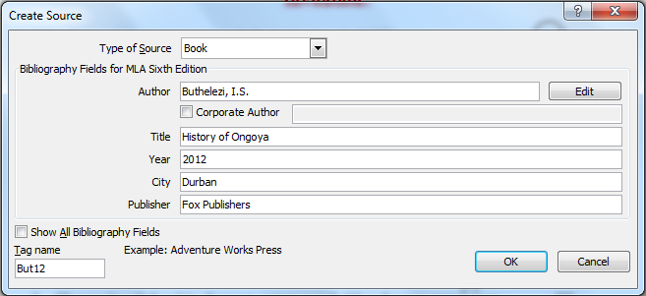

Total: 75 Marks

*************************** End of Paper *********************************

