University of Zululand
Website: http://www.unizulu.ac.za

Private Bag X1001
3886 KwaDlangezwa

Faculty of Education
Department of Mathematics, Science and Technology

Learner guide – 2019

Subject: Educational Computing

Subject Code: EEC591

Program:
B Ed (Hons) Professional

NQF level: 8

Credits: 12

Notional Hours: 120

Component: Fundamental

Table of content

No | Topic | Page
1. | INTRODUCTION | 2
2. | PURPOSE OF THE PROGRAMME | 3
3. | PURPOSE OF THE LEARNING GUIDE | 4
4. | sYLLABUS and OUTCOMES | 5
5. | LITERATURE | 7
6. | ASSESSMENT | 8
7. | GENERAL GUIDELINES | 10
8. | UNITS
 | 8.1. WORD PROCESSING: MLA DOCUMENTATION STYLE | 12
 | 8.2 SPREADSHEET SKILLS | 12
 | 8.3 PROJECT MANAGEMENT | 14
9. | ASSIGNMENTS | 14

1. INTRODUCTION

Welcome as learners, to the Educational Computing course. We would like to invite you to use the lecturer as facilitator to develop your knowledge in this subject to the maximum. In order to attain success in this subject, your own contribution is important. It is important that you realize that it is your responsibility to prepare for classes and to initiate class discussions. If your attitude towards your study is correct, success will inevitably await you in your future career.

We are going to build on the foundation laid in your undergraduate courses of Computer Literacy. The focus will be hence more on application and you will be exposed to more advanced topics of MS Word and MS Excel. During this module you will acquire new competencies to enhance your technological knowledge and skills but most importantly you will also acquire skills to facilitate the learning area of Educational Computing.

Overall the course can be divided into three sections: The first section on MS Word will be devoted to an introductory research topic, reporting on it in typical MLA style. It will also be expected from you to deliver a presentation on it. This is necessary for any 4th year of learning.
The second section will expose the learner to advanced topics in MS Excel, focusing on business- and statistical calculations.

The third section is a selected topic, MS Project, where you can apply the skills you mastered in the Excel classes. You are entering now the management level of school administration, and this exposure will strengthen just that.

This module is written in an outcomes-based format and the content is informed by the current policies and procedures of the Department of Education as well as the Norms and Standards for Educators. The application of current technologies as well as educational technologies also forms the basis of this module.

2. PURPOSE OF THE PROGRAMME

2.1 PREREQUISITES

As this is an Honours course you should have had some experience in computer literacy, as well as some experience with the calculation of some form of statistics/mathematics nature using a pocket calculator. More specific, you should be familiar with navigating in a Windows environment on a computer, the operation of the ribbon with its groups and buttons and the basic directory, using the file or folder tree structure for managing files.

IT IS ASSUMED THAT YOU HAVE ACCESS TO A COMPUTER AND THE INTERNET.

2.2 WHAT IS EDUCATIONAL COMPUTING?

Pocket calculators become inadequate when real life calculations (be it mathematical, statistical, or business-like) have to be performed. The calculations become too repetitive and complicated, as you may be experienced in a school environment! Computing in general consist of a study of the methods by which such calculations can be automated on a computer. The means by which this is achieved are:

- Programming a computer using a programming language like FORTRAN, C, PASCAL, JAVA etc. Procedures or functions or methods are written in programming code to perform calculations. The mathematical modeling/ analyses in any major project (e.g. at the level of Government or big businesses or a major research effort) would be tackled using these methods. The size of the data requires efficient code - even code using parallel computing. Some of the sub procedures may even have to be written in assembly language code to speed up its execution. A dedicated mathematician cum computer scientist would be required to do this.
- Modifying existing mathematical packages. There is a plethora of dedicated software available on the market. Some brand names (let’s take statistics as an example) are SASWICH, STATSGRAPHICS, SPSS and STATA etc. In the business environment PASTEL is very popular, especially for small businesses. The license fee for using them can cost a small fortune. Any professional, especially learners on a post-graduate course, will have to master one of these at some stage. This consists in working through the manual accompanying the software. The main difficulties are: adapting your data to that required by the software, knowing which particular mathematical procedure is required and finally interpreting the results produced by the software.
- Using a fifth generation language like MATHEMATICA, MAPLE etc. Its advantage is the integration of the theory and the practical aspects of a subject at all levels in one unit.
- Using a spreadsheet like LOTUS, or EXCEL: We will be using EXCEL to do our business and statistical calculations. It is affordable, readily available and quite adequate for most mathematical tasks. It is the ideal medium for instruction and at the end of the module you would hopefully share these sentiments.
- You will also do an introductory research paper, Assignment 1, working in pairs of TWO learners. It is expected from you to present it to the class using PowerPoint.
- Self-directed studies will be done in Assignment 2, where you will develop your own Website. Ques will be given in class!

With these objectives in mind, we aim to equip the student educator with the necessary competencies and skills in order to have skills, knowledge and understanding of the use of Technologies in order to effectively facilitate the learning area of computing.

2.3 LIMITATIONS OF THE COURSE

Unfortunately, because of the scope of the course, you will not be exposed to all the advanced concepts enabling you to do most of the statistical calculations required in a medium sized business or a medium sized research project using EXCEL. This is also true for project management. Surely it can assist in small projects in the school environment. But the standard will be set sufficiently high for you to be able to do routine computations and planning in your ordinary work environment.

2.4 IN CONCLUSION

It is important to realize that the International Society for Technology in Education (ISTE) recognizes that educational computing and technology foundations (NETS for teachers) are essential for all teachers. So with this in mind I developed this course, and I really hope you as learners will drive it to be a success. Your attitude will set your latitude!

3. PURPOSE OF THE LEARNER GUIDE

This learning guide serves as an instrument of preparation for the learner. It enables you to plan your studies and to follow the completion of the curriculum framework. The theory component of Educational computing will be compiled as a class exercise, wherein the learners participate actively. Homework will be given, and it is important to do it to make sure that you master the work. The practical component is hands-on and it’s very important that you attend the classes to improve your computer skills. The examination will be a hands-on exercise.

The content of this learning guide must not be regarded as complete. The accumulation of knowledge and insight, as well as the achievement of specific goals, is the learner’s primary responsibility. The learning process will be facilitated within the academic framework with the learning outcomes. The learner should therefore know which learning outcomes must be achieved after each session and what the learner will have to give account of at the end of the module.

WHILE the utmost care was taking during the compilation of this learning guide, it remains subject to change.

4. syllabus and outcomes:

A summary of the work to be done is as follows:

Educational Computing
Unit 1 | Project
Unit 2 | Spreadsheets
Unit 3 | Introduction to Project Management
Unit 4 | IT Tool

4.1. CONTENT

The content of the intellectual and technical offering is summarized as follows:

Unit 1:
- Project: Based on what is happening in the IT field, as applicable to the teaching environment.
- Use MS Word:
- Create a short research document according to the MLA style.
- PowerPoint:
- Creating a slide presentation covering the research topic and showing skills like:
- Create and design a presentation
- Using animations and transitions
- Enhance presentations using WordArt

Unit 2:
- MS Excel
- Revision: Drawing up a fundraising sheet, formatting, using the SUM function and Clustered Charting
- Creating a payroll report, using AVERAGE, MAX, MIN functions.
- Creating a sheet with financial projections, like sales, cost of goods, margins, etc., creating series, freezing panes, relative/absolute referencing, what-if analysis, goal-seek and charting
- Using financial functions like, vlookup, NPV, pivot tables and applying these skills to filters and amortization tables.
- Descriptive statistics: range, Count, CountIf, Activity, Frequency, and the Histogram,

Unit 3:
- Project Management
- Introduction to financial functions
- Creating Gant/Network charts
- Assigning durations and resources
- Applying financial skills determining the financial viability of the project

Unit 4:
- Introduction of an IT Tool.
- Developing a Website

4.2. LEARNER OUTCOMES

After working through and studying this module the learner should be able to apply:

- Terminology. The student will be able to explain the meaning of terms used to describe common techniques and concepts in educational computing.

- Skill. The student will demonstrate knowledge and understanding of computer skills within a technology learning area context. Specifically, to successfully use MS Word, Power Point, MS Excel, and MS Project.

- Advanced IT Concepts in Education. The student will be able to describe the ways in which technology can be integrated into the curriculum, using network communications, software and hardware as productivity tools, digital media, evaluating educational technology, and security- and ethic-issues.

- Research. The students will be involved in an introductory research project, using information technologies as an effective way to communicate, find information, reporting using MLA style and will gain experience working in a small group. All of these to enhance your work as a professional educator.

- Behavioral and Organizational Issues. The student will be able to identify and suggest appropriate responses to information technologies and educational issues stemming from integration, implementation, and evaluation of these concepts. The student must also realize IT’s impact or implications on education and the society at large

- International Issues. The student will recognize the reality of implementing IT in education, including economic and cultural differences.

- Social and Ethical Issues. The student will understand the major social and ethical issues involved in the development and use of information technology in education.

4.3. CRITICAL CROSS-FIELD LEARNING OUTCOMES

The critical outcomes state that learners will be able to:

- Identify and solve problems and make decisions using critical and creative thinking (problem-solving skills).

- Work effectively with others as members of a team, group organization and community (team-ship).

- Organize and manage themselves and their activities responsibly and effectively (self-responsibility skills).

- Collect, analyze, organize and critically evaluate information (information processing/research skills).

- Communicate effectively using visual, symbolic and/or language skills in various modes (communication skills).

- Use science and technology effectively and critically, showing responsibility towards the environment and the health of others (technological and environmental literacy and responsibility).

5. literature

5.1. Prescribed

G Shelly and M Vermaat, Microsoft Office 2010 Introductory, 2011, Cengage
ISBN 9781439078389

5.2. ADDITIONAL READING
All the books mentioned below are available from the UZ library’s short loan desk.

K S Proctor, Building Financial Models with MS Excel, 2nd Ed, 2010 Wiley and Sons
ISBN 978 0470481745. 658.150285 PRO

N J Salkind, Excel Statistics, A Quick Guide, 3rd Edition, John Wiley, 2011,
ISBN 9780470553107. 005.54 SAL

M Secrett, Mastering Spreadsheet Budgets and Forecasts, 2000, Pearson Education. ISBN 0273644912. 658.154 SEC

Turban, Rainer, Potter, Introduction to Information Technology, 2005, John Wiley,
ISBN 0471347809. 658.05 TUR

Pasework, Pasework, Microsoft Office 2010 Introductory, 2011, Cengage,
ISBN 9780538475181.005.5 MIC

E Neuwirth, D Arganbright, The Active Modeler: Mathematical Modeling with
MS Excel, 2004, Thomson, ISBN 0534420850. 511.80285 NEU

On order: B V Liengme, A Guide to MS Excel for Scientists and Engineers, 2013,
Microsoft.

5.3. RESOURCES

The lecture and practical notes will be posted on the Moodle, our LMS (Learning Management System).
Additional notes, communications, marks, old papers, memoranda, will be available there. You can download it, and print it if you wish

5.4. RECOMMENDED WEBSITES

The following websites will enrich your knowledge, and it is advisable to pay them a visit. More URL’s will be given to you during the semester.
http://www.webopedia.com, www.techweb.com/encyclopedia, and
http://en.wikipedia.org/wiki/Information_technology. All three sites provide definitions, explanations, and links for terms and concepts in the IT field. The latter site is part of Wikipedia, the excellent on‐line free encyclopedia (www.wikipedia.org).

5.5. COPYRIGHT AND PLAGIARISM

If you should make any copies of any book, you can be found guilty of a criminal offense and a fine or imprisonment can be imposed. The Faculty does not take any responsibility in this regard. If copies must be made, written permission must be obtained from the publishers of the book.

6. assessment

The assessment criteria must arise from, and be linked to, the intended outcomes. You as learners will be informed about the way in which you will be assessed. This means that you will be told what knowledge, skills and attitudes need to be acquired in order to achieve the outcomes.
While preparing for assessments, you must ensure that you meet all the outcomes and assessment criteria as stated in each learning unit.

6.1. FORMATIVE ASSESSMENT

Formative Assessment takes place during the process of teaching and learning with the purpose of developing the learners’ abilities. Formative Assessment will occur in the form of formal tests and assignments given by your lecturer. Formal tests and assignments will account for 40 % of your final mark. The test will be written during normal class times and the venue will be announced in due time.

Any test missed will count as a zero unless a valid medical certificate or reason is handed to your lecturer as soon as possible. A sick test will be written in such cases at the discretion of the lecturer.

6.2. DUE PERFORMED REQUIREMENTS

A student will NOT be permitted to write the final examination in a module if he/she fails to satisfy the minimum DP requirement. The requirements state that a student must achieve a DP of 40%. The DP will comprise tests, class work and assignments – at the discretion of the lecturer.

6.3 SUMMATIVE ASSESSMENT (FINAL EXAMINATION)

Summative assessment is undertaken to make judgment about the learners’ achievement and is carried out at the end of the learning program. A three hour examination will be written at the end of the semester on the work done during the semester. The summative assessment will account for 60 % of your final mark at the end of every semester. A final pass of
50 % is required to pass this module.

6.4 TYPES OF DELIVERY AND ESTIMATED NOTIONAL STUDY HOURS

Contact Study | Notional Hours | Self-Study | Notional Hours
Lectures/Practical | 42 | Research Based | 30
Tutorials |  | Self-Directed | 10
Field Trip |  | Self-Assessments | 8
Exam | 3 | Exam Preparation | 21
Tests | 6 | Presentations
Other
Total Contact: | 51 | Total Self Study: | 69
Total Notional Hours: 120

Methods of Assessment to be used: (% weighting)

Activity: | %
Formal end of Module Exam (3 Hours) Practical exam: | 50
Project (Including Presentation) : | 25
Web site development | 10
Test 1: Practical Hands-on, Introductory Excel | 5
Test 2: Practical Hands-on, Advanced Excel | 10
Total | 100

7. GENERAL GUIDELINES

7.1. CLASS ATTENDANCE

Class attendance is of the utmost importance in this subject. The practical application of theory is constantly done through a variety of class activities. Important announcements are made during the class and important guidelines are provided on how to start and complete homework and assignments.

STAYING AWAY FROM CLASS IS A GUARANTEED RECIPE FOR FAILURE.

Should you fail to attend class, it will be your responsibility to obtain relevant information from fellow learners.

BE PUNCTUAL FOR CLASS – BEING LATE IS A DEFINITE CHARACTERISTIC OF AN IRRESPONSIBLE INDIVIDUAL.

7.2. TIMETABLE

All lectures/practicals are lectured in the computer laboratory HP2.

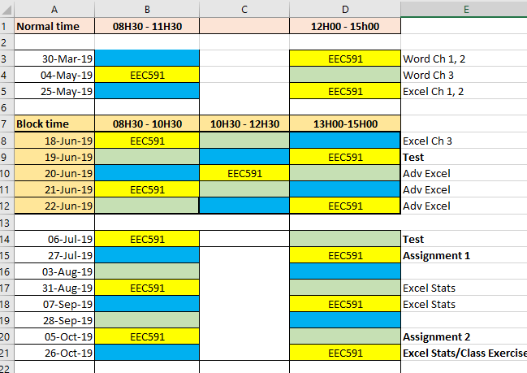

7.3. CONSULTATION OF COURSE FACILITATOR

Since this is a part-time course running on Saturdays and you are working individuals, you are encouraged communicating using the social network WhatsApp. Good performance is important to us, so we invite you to contact your lecturer via WhatsApp, or make use of Email, make an appointment for consultation time. The Email address is given in next section. Time will also be given in class to make appointments or discussing work.

No lectures, of any nature, missed because of poor class attendance, will be repeated during consultation hours - that is why classes are arranged. No notes / transparencies will be loaned to learners! No assignments / tests will be distributed to any learner in the course facilitator’s office – these will only be distributed in the classroom.

7.3. SCOPE OF WORK FOR ASSESSMENT PURPOSES

You are required to study all the work as set out in this learning guide.

Program Summary:

The 4th Industrial Revolution is suddenly on all South Africans lips! Africa is so behind, that in my humble opinion, I wonder if we will be able to catch-up. This doesn’t mean we are giving up. History proved that we as a nation always rise to the occasion.

You as the educators of the youth, have to rekindle IT at schools. It must start there. If you can succeed in that, it will be the best course summary ever.

7.4. COURSE FACILITATOR

Mr. BF Nel
Office No D210
D-Block
Email: nelb@unizulu.ac.za

Phone: (035) 9026187
--Cell: 0824827547

8. UNITS

UNIT | Learning Outcomes
UNIT 1  Word processing techniques: MLA documentation style  Project, project presentation | Displaying Formatting Marks, Changing margins, Adjusting Line spacing  Using a Header to Number Pages, Headers and footers, Entering text using click and type, Entering a page number into the header  Typing the body of a research paper, Applying formatting using shortcut keys, Saving the research paper, Indenting paragraphs, Using word’s autocorrect feature, Adding footnotes, Modifying a style, Using word count, Automatic page breaks, Recounting words in a document  Creating an alphabetical works cited page, Manual page breaks  Centering the title of the works cited page, Creating a hanging indent  Inserting arrows, faces and other symbols automatically  Creating a hyperlink, Sorting paragraphs  Proofing a revising the research paper, Going to a specific location in a document, Moving text, Smart tags, Finding and replacing text, Finding text, Finding and inserting a synonym, Checking spelling and grammar  Saving again and printing the document, Working with main and custom dictionaries  Navigating to a hyperlink, Setup g-mail, send and receive e-mail  e-mailing a copy of the research paper, using the research task pane  Enhancing documents using symbols, word- and clip-art  Entering formulae using Ms Equation 3.0  Contextualize into technology learning area:  - To be exposed to research, information searches, and to document it formally.
Presentation with MS PowerPoint
See page 17 for explanation
UNIT 2  Spreadsheet skills | Text and Numeric Entries: The information or data you enter in a cell can be text, numbers, or formulas. AutoCorrect: The AutoCorrect feature makes some basic assumptions about the text you are typing and, based on these assumptions, automatically corrects the entry.  Column Width: The size or width of a column controls the amount of information that can be displayed in a cell.  Spelling Checker: The spelling checker feature locates all misspelled words, duplicate words, and capitalization irregularities in the active worksheet and proposes the correct spelling.  Thesaurus: The thesaurus is a reference tool that provides synonyms, antonyms, and related words for a selected word or phrase.  Copy and Move: The contents of worksheet cells can be duplicated (copied) or moved to other locations in the worksheet or between worksheets, saving you time by not having to retype the same information.  Range: A selection consisting of two or more cells on a worksheet is a range.  Formula: A Formula is an equation that performs a calculation on data contained in a worksheet.  Relative Reference: A relative reference is a cell or range reference in a formula whose location is interpreted by Excel in relation to the position of the cell that contains the formula.  Function: A function is a prewritten formula that performs certain types of calculations automatically.  Recalculation: Excel automatically recalculates formulas whenever a change occurs in a referenced cell.  Alignment: Alignment settings allow you to change the horizontal and vertical placement and the orientation of an entry in a cell.  Font: Fonts consist of typefaces, point sizes, and styles that can be applied to characters to improve their appearance.  Style: A style consists of a combination of formats that have been named and that can be quickly applied to a selection.  Graphics: A graphic is a non-text element or object, such as a drawing or picture, that can be added to a document.  Chart: A chart is a visual representation of data that is used to convey information in an easy-to-understand and attractive manner. Different types of charts are used to represent data in different ways.  Chart Elements: A chart consists of a number of elements that are used to graphically display the worksheet data.  Chart Object: A chart object is a graphic object that is created using charting features included in Excel. A chart object can be inserted into a worksheet or into a special chart sheet.  Group: A group is two or more objects that behave as a single object when moved or sized.  Data Label: Data labels provide additional information about a data marker.  Headers and Footers: Heathers and Footers provide information that typically appears at the top and bottom of each page and commonly include information such as the date and page number.  Absolute Reference: An absolute reference is a cell or range reference in a formula whose location does not change when the formula is copied.  Sheet Name: Each sheet in a workbook can be assigned a descriptive name to identify the contents of the sheet.  AutoFill: The AutoFill feature makes entering long or complicated headings easier by logically repeating and extending the series.  Sheet and 3-D References: A formula containing sheet and 3-D references to cells in different worksheets in a workbook allows you to use data from other worksheets and to calculate new values based on this data.  Split Windows: The split window feature allows you to divide a worksheet window into sections, making it easier to view different parts of the worksheet at the same time.  Freeze Panes: Freezing panes prevents the data in the panes from scrolling as you move to different areas in the worksheet.  What-If Analysis: What-if analysis is a technique used to evaluate the effects of changing selected factors in a worksheet.  Goal Seek: Goal Seek is a tool that is used to find the value needed in one cell to attain a result you want in another cell.  Number Format: Number formats affect the appearance of numbers onscreen and when printed.  Enter data, arrange data and use formulas and functions  Generate charts and graphs  Contextualize into technology learning area:  - creating and editing a multi-data set 3-D column graph, pie graph,  - focus on the VLOOKUP function and compares to the IF statement in analyzing class marks and assigning grades  - use the PMT function,  - What-If-Analysis and Goal Seek,  - linking and embedding between Ms Word and Ms Excel
UNIT 3  Project Management | To create Gant/Network charts  Use basic financial functions to calculate project feasibility  Contextualize into technology learning area:  - to be able to develop and manage small scale projects in the school environment  - to learn basic financial functions to assist in any school environment
UNIT 4  IT Tools | To be exposed to developments in the IT field, and how we can apply it in the teaching field.  Contextualize into technology learning area:  - to apply Web technology in the school environment, increasing communication with learners.

9. ASSIGNMENTS

9.1. PROJECT/ASSIGNMENT 1

Preparing a Short Research Paper

Problem: In the light of the 4th industrial revolution, we cannot ignore the role of AI, or Artificial Intelligence. Research the topic, maybe start with Google, before you formalize your specific topic: AI in education.
Read on this topic and write a three-page paper that summarizes your findings. To summarize: So this has to do with “methods” to support learning through Intelligent and socially informed technology.
Due: Saturday, July 27, 2019

Requirements/Guidelines:
- Research the topic in general
- Organize your ideas
- Write the first draft, referencing sources
- The paper must contain 900 - 1000 words
- Create the list of sources
- Proofread and revise the paper
- The paper must be presented according to the MLA documentation style.
- Presentation to the class using Power Point.
- You must work in groups of two people.
Group Work: (Suggestions!)
Each team member is to write a minimum of 200 words summarizing his or her findings. Each team member also is to write at least one explanatory note and supply his or her reference for the works cited page. Then, the team should meet as a group to compose a research paper that includes all team members’ write-ups. Start by copying and pasting the text into a single document and then write an introduction, body and conclusion as a group. Use the concepts and techniques learned to format the paper according to the MLA documentation style.

PowerPoint Presentation
Why we have a slide show?
- You can deliver a dynamic, professional-looking message to an audience
- Enhances your oral presentation/effectively communicate your ideas
- Reinforce your message
- Help audience to retain the information presented.

The process of developing a presentation that communicates SPECIFIC information requires careful analysis and planning
- Why is the presentation needed?
- Analyze the intended audience
- Gather information about the TOPIC
- Decide what to include
- Design and style to successfully delivering the message
Topic: Energy conservation
1. It is easy being green
Green globe
Saving energy at home
Presented by BF Nel
Faucet
2. Make small changes to cut energy
Install low-flow faucets and shower heads
Cut water consumption in half
Appliances count for 20% of electric bill
Dishwasher
Buy ENERGY STAR qualified products
Run dishwasher, washing machine with full loads
Wash clothes in cold water
CFL
3. Use energy efficient lighting
4. Adjust your thermostats
Furnace
Furnace: 30 degrees
Geyser: 50 degrees
Water heater
5. Closing Slide/Conclusion
STEPS:
- Choose a THEME
- Create PP
- Insert pictures
- Transitions (special visual and audio effects to all slides: how it moves onto the screen)
- Animations (control the objects and text appearance on a slide)

TOPIC: How to save energy at home
- Drive the idea of going GREEN
- Cut energy at home: faucets, running appliances
- Introduce CFL lights
- Setting of thermostats
- Conclusion

Theme: Oriel theme
Insert clipart…green globe

IT IS EASY BEING GREEN
Saving Energy at home

Small changes at home:
Install low-flow faucets and shower heads
Cut consumption in half
Appliances count for 20% of electric bill
Energy star
Dishwasher, clothes washer
INSERT SOME clip art pictures

Picture of CFL bulbs

Adjusting of thermostats COMPARING furnace and geyser
Furnace Geyser

9.2. ASSIGNMENT 2

Web Home Page Construction
Due: Saturday, October 5, 2019

In this assignment, you will construct a simple personal web site, consisting of at least two connected web pages: “Home” and some other page. Your home page, which can be kept simple, must include, at the minimum:
- A greeting
- A short paragraph explaining its purpose
- Some image/picture/graphic (e.g. your photo)
- A list of at least three study or work related links
- At least one fun or extracurricular related link
- A clearly labelled direct link to your second web page
- A Java applet (see teaching note for details)
GGGGYour web page will be accessible to the whole world! Therefore, you should apply appropriate discretion when choosing the content of your page. If you do not wish to publish anything about yourself on the home page, you can also choose an alter ego for this assignment.
Detailed information on constructing and publishing your home page can be found on a teaching note, which is distributed. The teaching note will also explain how to insert your photo and include links to the web sites. Having created your web site with home and additional pages be sure to publish it on the server (or any other server that you have access to), and access it from a browser to make sure it works as you intended.

The only thing you need to submit for this assignment is the URL of your home page.

IMPORTANT NOTE: If you already have a home page that you created yourself and that satisfies the above minimum requirements, you may simply submit the URL of your existing home page. Also, feel free to develop your page using whatever tools you are most comfortable with. Finally, you may publish your page on any server you have access to.

Important Notes:
- You are encouraged to work in teams of 2 for these assignments. If you do, the same grade will be given to both members. Collaboration is an important skill, and have to be developed. In this case, that means that both team members must be present when the work is being done, and both must understand the final answers. If team member A is substantially more knowledgeable about the subject matter than B, it is A’s responsibility to explain the reasoning behind the answers to B, and it is B’s responsibility to ask questions until B understands the answers.
- Do not leave the assignments for the last minute!

9.3. PRACTICAL

MS Word Exercise 1:

Found Dog

Adorable, loving, friendly, well-behaved dog found early Friday morning, June 1, wandering on the bike trail at Filcher Park in Hampton Township.
Tan color with patches of white on his chest
Male, adult cocker spaniel
Green and silver collar with the name, Bailey, on the tag
If this is your lost dog, call 555-1029.


MS Word Exercise 2:

Ntombi Mthethwa
Mr. Nel
Educational Computing EEC591
April 4, 2015
Triangulation
How is a Nintendo Wii game console able to determine the location of a Wii Remote while a player interacts with a game? The answer is triangulation, a process that determines the location of an object by measuring the angles from two or more fixed points.
Surveyors often use triangulation to measure distance. Starting at a known location and elevation, surveyors measure a length to create a base line and then use a theodolite to measure an angle to an unknown point from each side of the base line (Jains 30-48). The length of the base line and the two known angles allow a computer or person to determine the location of a third point.
Similarly, the Nintendo Wii game console uses triangulation to determine the location of a Wii Remote. A player places a sensor bar, which contains two infrared transmitters, near or on top of a television. While the player uses the Wii Remote, the Wii game console determines the remote’s location by calculating the distance and angles between the Wii Remote and the two transmitters on the sensor bar. Determining the location of a Wii Remote is relatively simple because the sensor bar contains only two fixed points: the transmitters.
A more complex application of triangulation occurs in a global positioning system (GPS). A GPS consists of one or more earth-based receivers that accept and analyze signals
sent by satellites to determine a receiver’s geographic location. GPS receivers, found in handheld navigation devices and many vehicles, use triangulation to determine their location relative to at least three geostationary satellites. According to Sanders, the geostationary satellites are the fixed points in the triangulation formula (Understanding Satellites and Global Positioning Systems).
The next time you pass a surveyor, play a Nintendo Wii, or follow a route suggested by a vehicle’s navigation system, keep in mind that none of it might have been possible without the concept of triangulation.

Works Cited
Cordoba, Nicolas E., and Kara A. Sarkis. The Surveyor's Theodolite Formula. Orlando: Orange County Press, 2012. Print.
Jains, Malila. "How Surveyors Measure Distance and Calculate Angles." Today's Modern Surveyor Mar. 2012: 30-48. Print.
Sanders, Gregory B. Understanding Satellites and Global Positioning Systems. n.d. Course Technology. Web. 27 Feb. 2012.

MLA Documentation Style:
Style:
- 12-point Times New Roman
- Double Space
- Margins are set at 2.5 cm
- Use a header with your name and the page number in the right hand corner
- Your name, super visor, course, and date are on the left margin
- Have a title, centered
- Each paragraph is indented 1.27 cm ≈ 1.3 cm
- Works cited (parenthetical references) is used to refer to the bibliographical list of sources at the end of the paper.
- Can use foot notes
Procedures:
- Change document settings (Styles, line and paragraph spacing)
- Header: name and page number
- Enter name and course information
- Title
- First line indent
- Citations (Bibliography style, citations, create a source)

Examples:
“…..An angle to an unknown point from each side of the base line (Jains).”

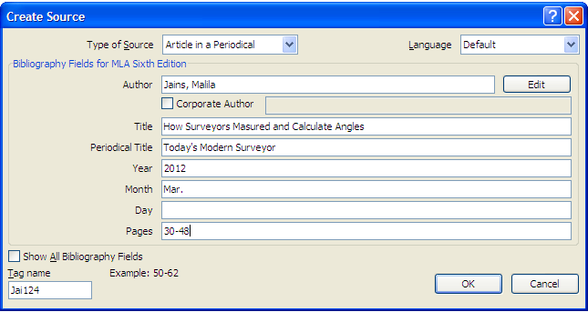

(Cordoba and Sarkis)
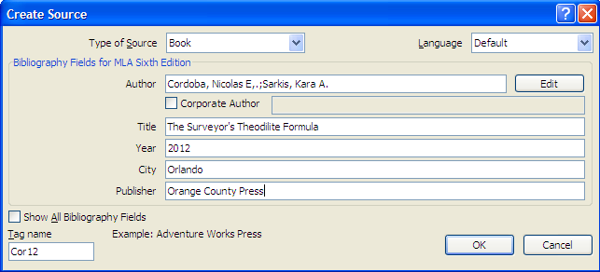

(Sanders)
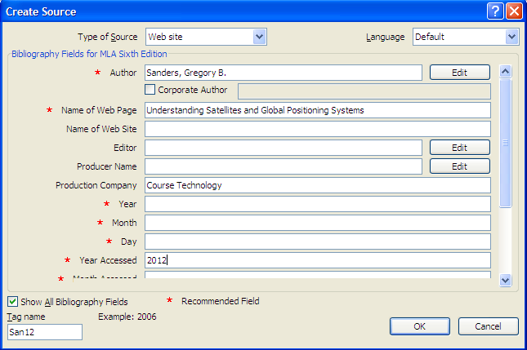
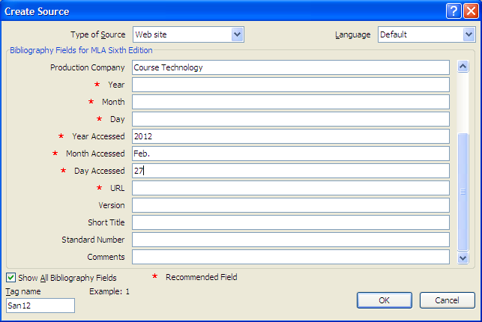
Footnote: Remember it must have the same format as the rest of the paper!!
………third point
- Right click in the footnote
- Select style
- Modify
- Change to Times Roman, 12, double space
- Click Format, select paragraph
- Click special box, select first line

MS Word Exercise 3:



Excel Practicals:

MS Excel Practical 1:
The data looks like this:
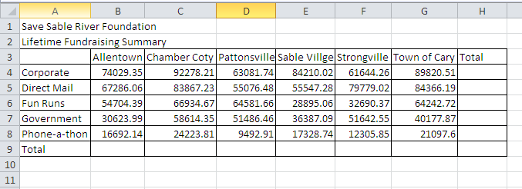

After some formatting (will be demonstrated) the sheet must look as the one below. Note on the sheets below, how the SUM function is applied for the column- and the row totals:

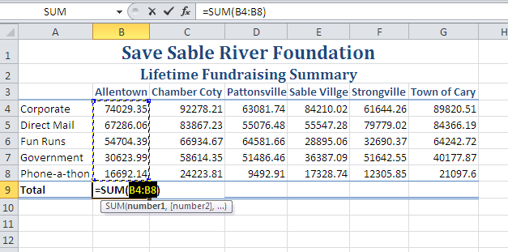

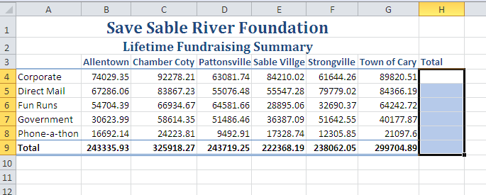
Sometimes to understand a lot of data or even certain mathematical concepts, like those in our spreadsheet, we will apply a visual model, or in our case it will take the form of a graphical representation or simply a graph. Well, what is a graph?
Before we do that, let us first look at a rectangular coordinate system or the Cartesian Plane: this consists of a horizontal line and a vertical line, which intersect at their zero points.

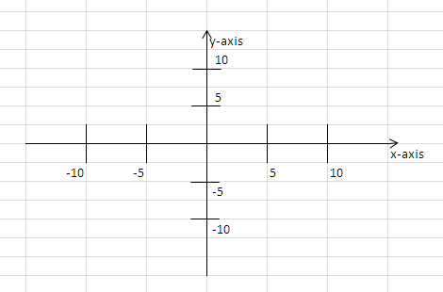

But this plane consists of an infinite number of points, called an ordered pair, consisting of the values (x, y). Consider the point P in the plane:

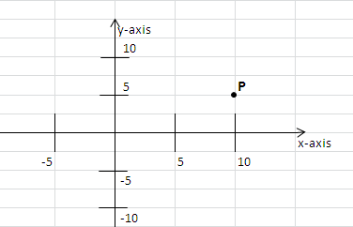

This point P(x, y) is described by the x-coordinate 10 and the y-coordinate 5 or just (10, 5). This simple observation will assist us now to draw or plot a graph!
We actually just describe two variables, x and y, and they sometimes relate to each other in one or other way. All we have to do is to mark all these different ordered numbers on the plane and then connect them!

Example:

x | y
4 | 2
2 | 3
0 | 4
-2 | 5
-4 | 8

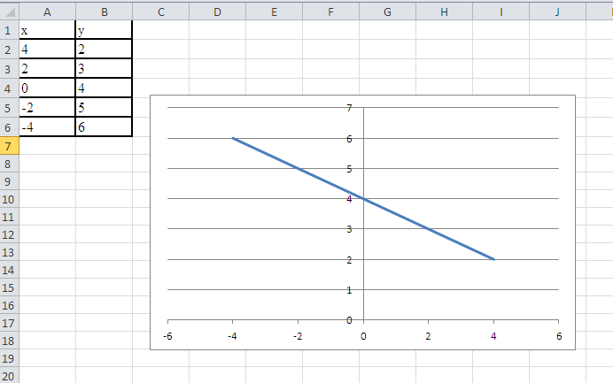

If you investigate the graph careful, you will find that we have drawn a graph representing the two-variable equation
2x + 4y= 16
Verify it!
Hint: Try to rewrite it as y= 4 – 1/2x? Supply some x-values, and calculate the corresponding y-value to obtain the order pairs as in the above table! This is a very important concept: for each x-value, there is a corresponding y-value.

Now back to our data in the spreadsheet on page 12: we would like to see each town’s and its contribution or in terms of ordered pairs:
(city, contribution)

For example (Allentown, 74029);
(Allentown, 67286);
(Allentown, 54704);
(Allentown, 30623) and
(Allentown, 16692)
This is a problem, because suddenly ONE x-value, takes on MANY y-values, and this is true for each town! To solve this we won’t draw a line graph, but rather a column graph to show the many contributions for each town!

To identify the different contributions for each town, we will include in our graph the ‘legend’, consisting of the labels Corporate, Direct Mail, Fun Runs, Government and Phone-a-thon. Luckily excel is quite clever and will recognize the legend. So you can include it with the data. So high light the range A3:G8 (must always take the form of a rectangle!), and select Insert > Column and select the appropriate chart:

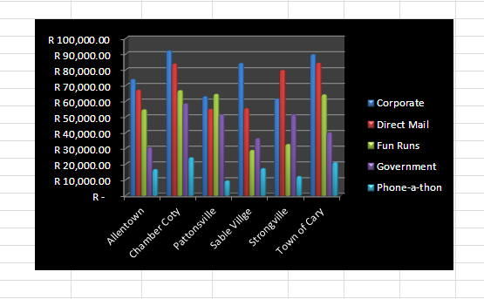

More graphs:
(In-house Computers vs. Outsource Services) A large medical group practice has grown fast over the years, with the billing being done manually by clerks. Because of this heavy volume, management wants to weigh their options up against either doing it themselves or outsourcing.
Very interesting, they found that the cost of both alternatives is dependent or a function of the number of patient bills.
- One of the Services will provide it at an annual flat fee of R 3000, plus R 0.95 per bill processed
- In-house will require a cost of R 15000 per year and an estimate of R 0.65 per bill.
- Putting it mathematically:
  - Service(x)= 3000 + 0.95(x), if x is the number of bills and
  - Leasing(x)= 15000 + 0.65(x).
Problem: Draw a billing-cost function for both options, and determine from the graph the number of patient bills necessary to break even!

You suppose to get a graph like the one on the next page:
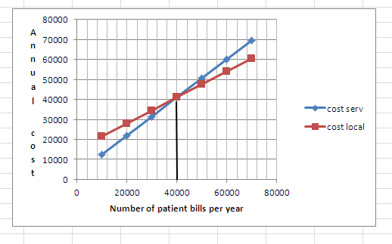

What is the meaning of the vertical dark line?

So when is the lease option less costly, and when is the outsource option less costly?

MS Excel Practical 2:
The first sheet is the original data and the second the outcome after formatting:

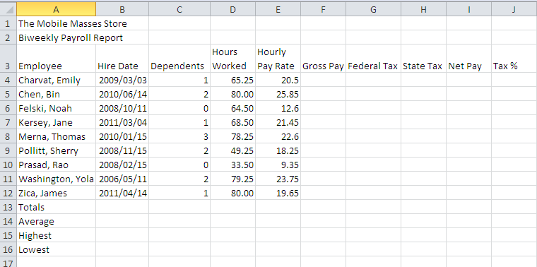

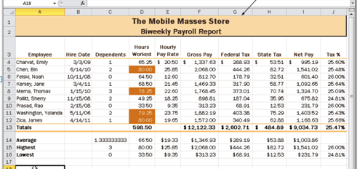

MS Excel Practical 3:
The first sheet is the data and the other sheets are the outcomes after formatting:

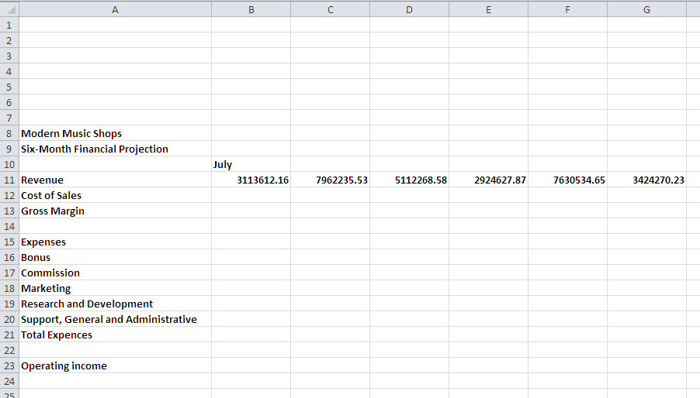

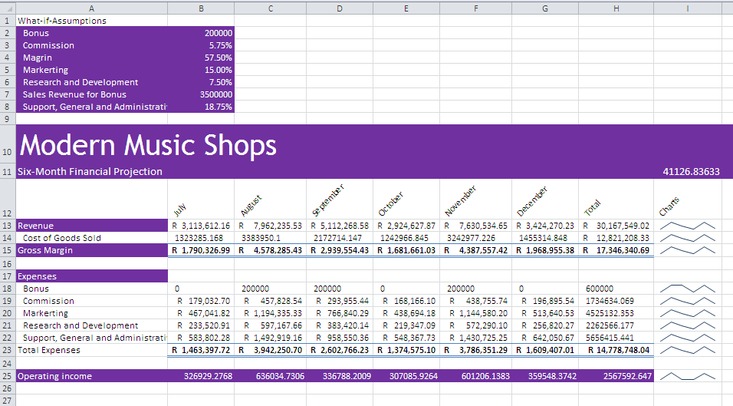

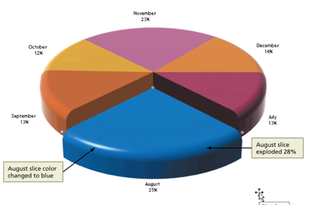

NOTE: you are now ready for the 1st practical test!

Amortization and Excel
Outcome: To be able to calculate a loan schedule, showing the payment, the capital or principal, interest and the amount outstanding.
Example: Draw up an amortization table for a customer, who likes to buy a house of R100 000 at an interest rate of 6% per annum, compounded monthly. They also want to know the monthly payment if the loan must be repaid over 20 years.
This problem deals with finance, interest rates, and repayment period. You have to master the following: If you do not know a function, you must make use of the help files. Like now you want to know more about “how to calculate a monthly payment”. Do the following: Select Formulas > Financial and browse to find a suitable function. The functions IPMT, PMT and PPMT seem to be relevant. At this stage as an inquisitive student, you would find out more about these different functions, and select the proper one!
With appropriate headings and the values of the problem in cells beneath it insert the right function to do the calculation. Don’t panic, I will assist you! How many months are there in 20 years?
Work out the first two lines of your repayment schedule i.e.
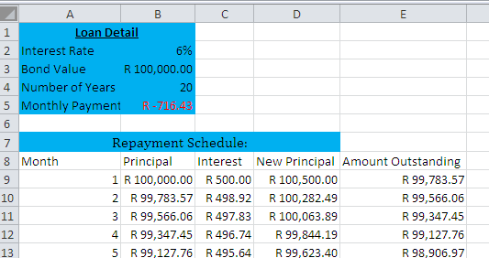
COPY the formula
Calculate this!

The payment calculation:
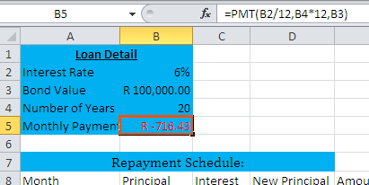

The first two rows of the payment schedule:
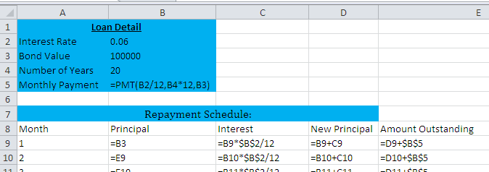
At this stage you must start to agree with me that Excel ‘is cool’!!

What-If-Analysis
The automatic recalculation feature of Excel is a powerful tool that can be used to analyse worksheet data. This means that we can scrutinize the IMPACT of changing values in cells that are referenced by a formula in another cell is called what-if-analysis or sensitivity analysis.
Class Exercise:
i. What will happen if we change the loan amount from R 100 000 to R 200 000? Well go to cell B3 and change it to 200000, and press enter. Notice how all the values change immediately.
What is the new monthly instalment?
What is the total Interest amount over the period?
ii. What will happen if we change the interest rate to 12%? Well go to cell B2 and change it to 0.12, and change the loan amount back to 100000, and press enter. Notice how all the values change immediately.
What is the new monthly instalment?
What is the total Interest amount over the period?

Homework 1
Prepare an amortization schedule for a debt of R5 000 bearing interest at 12%, compounded monthly, if the debt is amortized by a series of monthly payments for 1 year.

Exercise:
Let’s introduce an interactive scrollbar, as an alternative to ‘What-if-Analysis’:
Notes:

Challenge: Create an interactive toolbar for changes in the interest!!

Cost-Benefit Analysis using Excel 2016
When organizations evaluate the financial feasibility of investment decisions, the time value of money is an essential consideration. This is particularly true when a project involves cash flow patterns which extend over a number of years. We will discuss Discounted Cash Flow (DCF), Net Present Value (NPV) and Payback Analysis as tools to assess the profitability of a project.
- DCF
DCF is most often used to describe the calculation whereby the rate of interest is found which equates the present value of the negative and positive cash flows from a particular investment, where the negative flows have to do with costs and the positive flows are anticipated profits from the investment. Formally this is solving the equation
$$A= \frac{C_{1}}{1+r}+\frac{C_{2}}{{(1+r)}^{2}}+…+ \frac{C_{n}}{{(1+r)}^{n}}$$
Where A is the capital outlay;
C₁, C₂, …… are the end-of-year cash flows arising as a result of the outlay
r is the rate if interest for which the equation is solved.
  - Internal Rate of Return (IRR)
This is the rate which is found as the solution of a DCF calculation. It is thus the rate which is specifically relevant to the expected outcome of the project being considered and thus is internal to it as opposed to external rates of return such as money market yields.

Though there is no formal convention this rate is usually designated as r.

  - Example
A project is being considered by a company the details of which are:
Capital cost of R 1000.00
Positive cash flows of R 500, 600 and 400 respectively at the end of year 1, 2 and 3.
What is the IRR for this investment?
Capital cost End of year cash flows
1 2 3
R 1000 R 500 R 600 R 400

OPEN Excel, and set up the outlay as follows:
(Note: To find the IRR function, click on ‘Insert Function’, select as category ‘Financial’, and select ‘IRR’.)
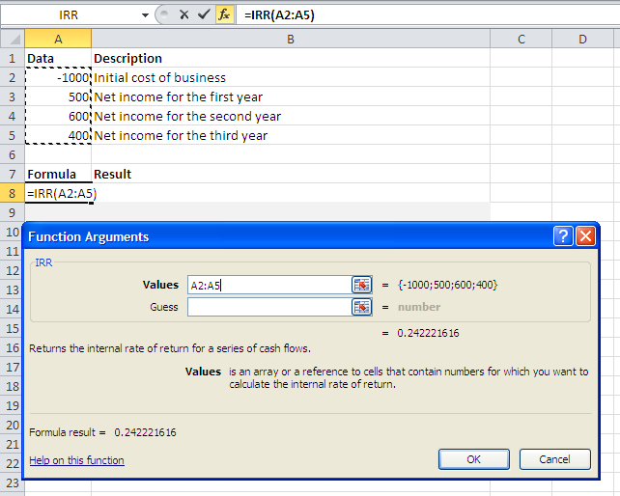
Although the answer is 24.22%, it is unlikely that the cost and cash flow estimates would justify such spurious accuracy and the IRR can be taken as 24%.
1.3 Exercise
A company is considering two mutual exclusive projects, the details of which are as follows:
Capital cost End of year cash flows
1 2 3
Project A R 1000 R 100 R 1000 R 653
Project B R 1000 R 600 R 600 R 374

Show that the DCF returns are:
Project A 28%
Project B 29%
- NPV
This method is an alternative to DCF whereby a rate of return is assumed, (e.g. a company’s cost of capital), and the cash flows are discounted to the time that the initial capital outlay was incurred. The net difference between initial capital outlay and the discounted cash flow is a commuted measure of the project’s expected contribution to profit, if positive.
2.1 Example
Using the same data as Example 1.2 the company is prepared to consider any investment yielding 20% or over as this rate is considered to represent a reasonable rate of return.
The present value of the cash flow is
$$PV= \frac{500}{1.2}+ \frac{600}{{1.2}^{2}}+\frac{400}{{1.2}^{3}}$$
But we will use Excel to solve the above, using the NPV function!!
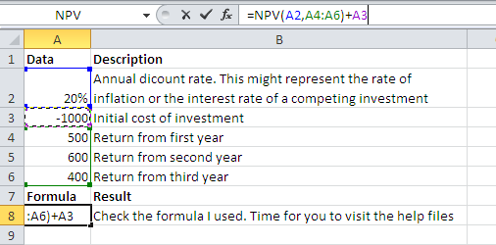
When executing this formula, you will find that the NPV = R 65, which can represent the commuted value of the profit which will accrue in the addition to the acceptable level of IRR.
2.2 Exercise
Use the data of exercise 1.2 and calculate the NPV’s of the two projects if the company is prepared to consider all projects that have a return in excess of 20%.
Capital cost End of year cash flows
1 2 3
Project A R 1000 R 100 R 1000 R 653
Project B R 1000 R 600 R 600 R 374

Show that the NPV’s are;
Project A R156
Project B R133

2.3 Interpretation of results (Not in the syllabus)
This illustrates the features of different decision processes. If capital is available, and the cost of obtaining it is known, NPV would rank A first but would recommend both A and B.
However if there is a competition for capital, then on a DCF basis B rank before A
3. Homework 2
A company is considering two projects the details of which are:
Capital cost End of year cash flows
1 2 3
Project A R 2000 R 700 R 1000 R 1370
Project B R 1000 R 300 R 700 R 609

Calculate:
1. Calculate the DCF’s returns of the two projects
2. Calculate the NPV assuming a rate of return of 15%
Answers:
1. 22%, 25% respectively
2. R 266, R 191 respectively
3. Payback Analysis
Payback analysis is the process of determining how long it takes an information system to pay for itself. The time it takes to recover the project’s cost is called the payback period.
To perform such an analysis, you carry out the following steps:
i. Determine the initial development cost of the project
ii. Estimate annual benefits
iii. Determine annual operating costs
iv. Find the payback period by comparing total development and operating costs to the accumulated value of the benefits produced by the system.
3.1 Example
Consider the following cost-benefit table:

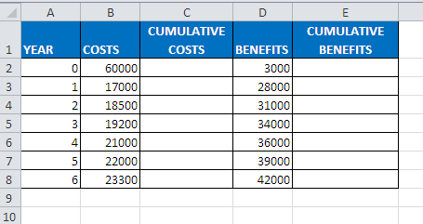
Task:
i. Copy the above table in Excel
ii. Use formulae to calculate the accumulative costs and benefits
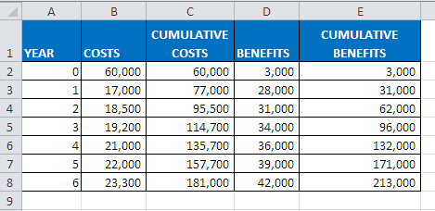
Year 4

0 1 2 3 4 5

60,000 77,000 95,500 114,700 135,700 157,700

iii. By inspecting the table, determine when the cumulative benefits exceed the cumulative costs:
Answer: At the end of year 4, the cumulative costs (135,700) are slightly larger than the cumulative benefits (132,000). During year 5, the cumulative benefits (171,000) far exceed the cumulative costs of 157,700. Therefore, at some point in time during Year 5, the accumulated costs and benefits are equal, establishing the payback period.
iv. Determine the payback period graphical:
Check out the graph on next page:
It looks like 4.2 years? What is 0.2 of a year? You agree it is about 2½ months?
Payback period is 4 years, 2½ months
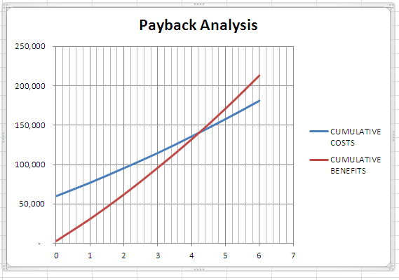
v. Use Excel and calculate the Return on Investment (ROI):
ROI is a percentage rate that measures profitability by comparing the total net benefits (the return) received from a project to the total coats (the investment) of the project.
$$ROI= \frac{Total Benefits-Total Costs}{Total Costs}$$
From Excel, ROI = 18%

Homework 3
Consider the following cost-benefit table:
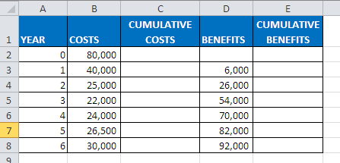

i. Use Excel and calculate the cumulative costs and benefits
ii. Estimate the payback period from the table
iii. Determine the payback period graphical
iv. Determine the ROI, in cell B10
Summarizing ALL of the above in ONE Excel sheet!
Consider the following project, consisting of yearly benefits, development costs, as well as yearly on-going costs:
 | Year 0 | Year 1 | Year 2 | Year 3 | Year 4 | Year 5 | TOTAL
Value of Benefits |  | 889000 | 1139000 | 1514000 | 2077000 | 2927000
Development Costs | -1336000
On-going Costs |  | -241000 | -241000 | -241000 | -241000 | -241000
To analyse this we need to determine the PV’s and the NPV’s. We will do it, but we also introduce the Cumulative NPV. You will realize now the advantages! Assume a discount rate of 10%, giving the following discount factors:

Year | Discount Factor
1 | 0.9091
2 | 0.8264
3 | 0.7513
4 | 0.6830
5 | 0.6209

Create the following spreadsheet:
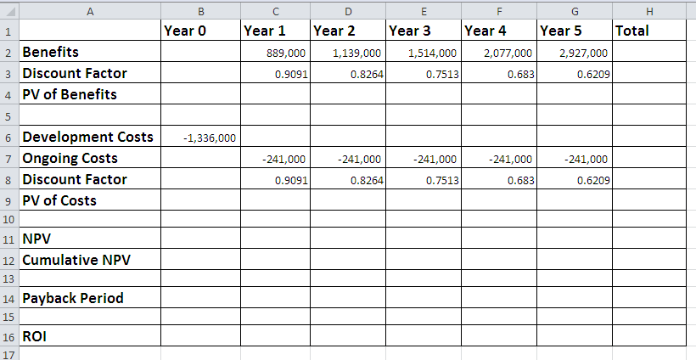
i. Calculate the PV of benefits, and their TOTAL: cell H4
ii. Calculate the PV of costs, and their TOTAL: cell H9
iii. Calculate the yearly NPV
iv. Calculate the Cumulative NPV. What is the meaning of the value in cell G12?
v. Payback period/breakeven point: the year the running accumulated NPV turns positive, is the year in which payback occurs. Here we also introduce ‘Interpolation’.
vi. ROI? Why don’t you try it!
Hint: Do the calculations step by step! The only extra work is to determine the Discount Factors.
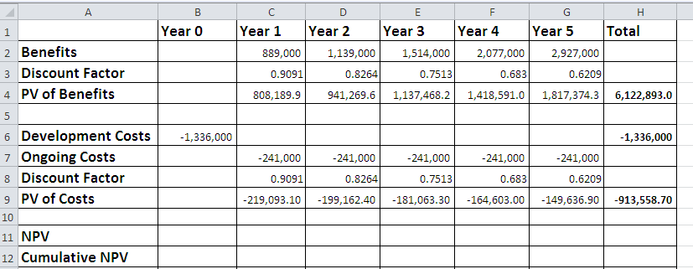
At this stage you can determine the NPV of the project! How much?

Complete the rest of the sheet:
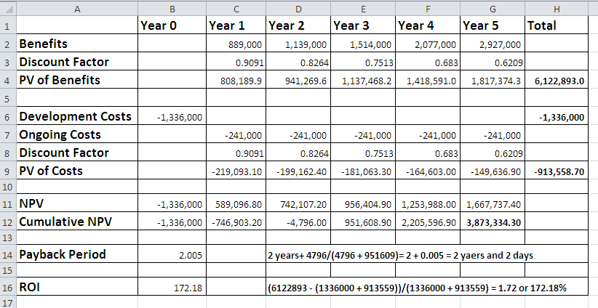
If you interested you can Google ‘Linear Interpolation’, to shed light on the calculation of ‘Payback Period’!
Homework 4: Develop a NPV spreadsheet, similar to the one above, but at a discount rate of 8%.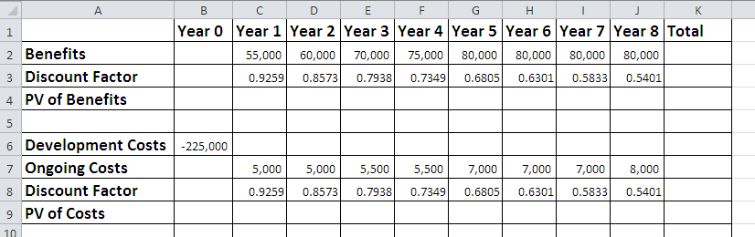
Draw a column chart, using B1:G1 against B12:G12, confirming the payback period. Marks will be allocated for title, and labels to axes.
Adding a data series to an existing chart
Sometimes we will have already created a graph and then decide that we also want to plot tha graph of another function over the same range of x-values.
Consider the function f(x) = x³/12, in the range -4 to +4: (use Excel to calculate column B, and draw a graph!)
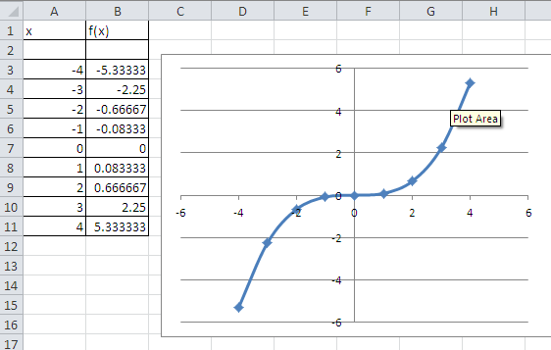
Next we want to include the graph of the inverse function by reversing the roles of the x- and y-values:
x | f(x) | x | f⁻¹(x)
-4 | -5.3333
-3 | -2.250
i.

ii. Select the chart of f(x)
iii. In the Data group on the Chart Tools design tab, click the Select Data button
iv. Select the ranges for the series values
v. Click OK
vi. Fine tuning will be done in class
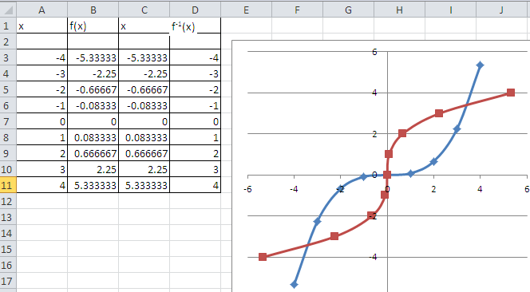
Comments on homework, Excel Chapter 2, EX131, Fig 2-79:
Instruction Part 2:
“Manually increment each of the six values in the revenue column by $1,000,000 until the lowest ending balance in cell F12 is greater than zero”

Example:
What will be the value of A4, when A2 = 6000? We will increment A2 manually in steps of 500.
This is a nice application of an Interactive Scroll Bar.

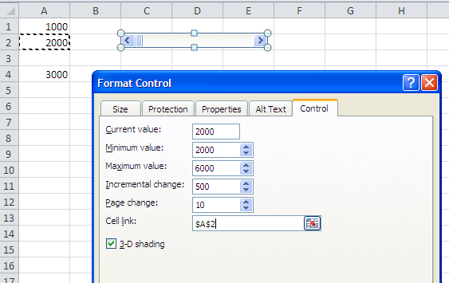
Answer: A2 = 5000
Project Management
Creating an IS, the following tasks were identified:

TASK | DESCRIPTION | DURATION  (DAYS) | PREDECESSOR  TASK
1 | Develop Plan | 1
2 | Assign Tasks | 4 | 1
3 | Obtain Hardware | 17 | 1
4 | Programming | 70 | 2
5 | Install Hardware | 10 | 3
6 | Program Test | 30 | 4
7 | Write User Manual | 25 | 5
8 | Convert Files | 20 | 5
9 | System Test | 35 | 6
10 | User Training | 20 | 7, 8
11 | User test | 25 | 9, 10

Task:
- Use the above information and create a WBS (sequential time line) using Ms Project. (Gantt Chart)
- Convert the Gantt Chart into a PERT chart.
- Create and add at least four resources of your choice.

************************************** The End *****************************

http://cnets.org
Cordoba and Sarkis state that electronic theodolites calculate angles automatically and then send the calculated angles to a computer for analysis (25).

