University of Zululand
Website: http://www.unizulu.ac.za

Private Bag X1001
3886 KwaDlangezwa

Faculty of Commerce
Administration & Law
Department of Accounting and Auditing

Module Title | Management Information Systems 1.1
Module Code | CAMS101
Programme in which the module is offered | National Higher Certificate: Accounting
Year of offering | 2017
SAQA Credits | 15
NQF level | 6
Name of Lecturer | Mr BF Nel

27 November 2016

Dear Student

Welcome as learners, to the IT course: Business Information Systems. We would like to invite you to use the lecturer as facilitator to develop your knowledge in this subject to the maximum. In order to attain success in this subject, your own contribution is important. It is important that you realize that it is your responsibility to prepare for classes and to initiate class discussions. If your attitude towards your study is correct, success will inevitably await you in your future career.

This course, the first of two semester courses, is designed to introduce students to the techniques and tools of management information systems. Coverage is given to the Information System, as it relates to the system’s concept, and their role in an organization; IT infrastructure with the focus on hardware and software, and database technologies. Students will learn social and global subjects such as ethical-, legal- and security issues relative to Management Information Systems. Computer literacy will be focused on creating word documents, power point presentations and data management.

Purpose of the learning guide

This learning guide serves as an instrument of preparation for the learner. It enables you to plan your studies and to follow the completion of the curriculum framework. For the theory component of Business Information Systems, it is important to do the review questions after each chapter, to make sure that you master the work. The practical component is hands-on and it is very important that you attend the practical sessions to improve your computer skills.

The content of this learning guide must not be regarded as complete. The accumulation of knowledge and insight, as well as the achievement of specific goals, is the learner’s primary responsibility. The learning process will be facilitated within the academic framework with the learning outcomes. The learner should therefore know which learning outcomes must be achieved after each session and what the learner will have to give account of at the end of the module.

Lecturer’s expectations

As the facilitator my expectations from you, as a learner, is to work hard, read the relevant literature before class and diligently do your homework and assignments. Prepare well and timeously for your tests and hand in assignments of a good quality on time. Be the best student you can be.

Lecturer’s contact details

Office no: A2-29 Richards Bay Campus
Office telephone: 035 902 6187
E-mail address: nelb@unizulu.ac.za
Department: Accounting and Auditing
C/o secretary: Mrs K. Adlam
A2-17 (Richards Bay Camus) Tel: 035 902 6924

TABLE OF CONTENTS
Page
- Definition of terms 3
- Generic outcomes 4
- Module purpose 5
- Module outcomes 5
- Topics with scheduling 5
- Notional hours 6
- Consultation times 6
- Mode of delivery 6
- Assessment procedures 6
- Assessment criteria 6
- Guidelines for presenting assignments 8
- Reference style 8
- Prescribed readings, and additional (recommended) readings 8
- Materials needed for the module 9
- Plagiarism 9
- Detailed outcomes 10 – 21

- DEFINITION OF TERMS

- Learner/study guide: A learner/study guide helps in organising lecture notes and textbook material so that students can increase their comprehension and memory of large amounts of information. Specific outcomes on topics covered, the summary of content, as well as revision questions are included.

- Tutorial: A tutorial is an interactive method of transferring knowledge in the learning process. A tutorial seeks to teach by example and supply the information to complete a certain task.

- Practical: A practical is a lesson in which theories and procedures learned are applied to the actual making or doing of something.

- Formative assessment: The goal of formative assessment is develop and monitor student learning to provide ongoing feedback that can be used by lecturers to improve their teaching and by students to improve their learning.

- Summative assessment: The goal of summative assessment is to evaluate student learning at the end of an instructional unit by comparing it against some standard or benchmark.

2. GENERIC OUTCOMES

After working through and studying this module the learner should be familiar with:

- Terminology. The student will be able to explain the meaning of terms used to describe common techniques and concepts in business information systems.

- Skill. The student will successfully use MS Excel, and Project management techniques.

- Advanced Information Systems Concepts. The student will be able to describe the ways in which computers are and will be used in business and management. These concepts will be introduced especially in E-Commerce and future directions of computer‐based ISs.

- Research. The students will be involved in a small‐scale Project Management development and will gain experience working in small teams.

- Behavioral and Organizational Issues. The student will be able to identify and suggest appropriate responses to managerial and organizational issues stemming from development, implementation, and use of computer‐based ISs.

- International Issues. The student will recognize the reality of implementing international ISs, including economic and cultural differences.

- Social and Ethical Issues. The student will understand the major social and ethical issues involved in the development and use of information technology.

- MODULE PURPOSE
This program is a support course for commerce and specifically accounting students, and is based on the IS 2015 Model Curriculum and Guidelines for undergraduate degree programs in information systems. These standards are well summarized in an article by Prof S Wang of the University of Massachusetts: An Examination of the Introductory MIS Course, Journal of Information Technology Education Volume 6, 2007. Although this is based on the 2002 Curriculum I found it very helpful.

On the one hand you will be exposed to the functioning of Information Systems in businesses, and how to apply technology strategically for a competitive advantage. On the other hand you will develop skills in especially MS Excel and Project management. All of the above will improve your computer literacy, a sought after skill in your career.

4. MODULE OUTCOMES

Students who successfully complete this course will be “computer literate” with a working knowledge of a variety of business software. They will understand the capabilities of computers and will be able to apply them to their own environments. Students will be able to:

- Describe how communications and network technology is used.
- Understand the role of and use the Internet.
- Identify the different categories of e-commerce and technologies and impact on business.
- Define and analyse typical functional information systems and identify how they meet the needs of the firm to deliver efficiency and competitive advantage, from enterprise systems to support systems.

5. TOPICS WITH SCHEDULING
Theory, referencing the prescribed book:
Week | Topics | Chapter  Readings
2, 3 | Data Communication | Chapter 6
4-6 | The Internet, Intranet and Extranets | Chapter 7
8, 9 | E-Commerce | Chapter 8
10, 11 | Enterprise Systems | Chapter 11
 | Test
12, 13 | Management Systems for Support | Chapter 12

Practical, refers to MS Office 2010 Introductory:

Week | Topics | Chapter  Readings
2 | Creating a worksheet and an embedded chart | Chapter 1
3, 4 | Formulas, functions and formatting | Chapter 2
6,8 | What-if analysis, charting and working with large worksheets | Chapter 3
 | Test
9 | Amortization | page 34, 35
10 | Cost benefit analysis: NPV | page 36-45
11 | Interactive Scroll Bar | page 46,47
11 | Project Management | page 46,47

6. NOTIONAL HOURS
The number of hours that this module has been allocated on the timetable is 5 x 45 minute periods. Notional learning hours are hours that are used for the learning activities and assessment of the module such as lectures, tutorials, practicals, presentations, independent study etc. The number of notional hours for this module accumulates to 150.

Notional Hours:
Contact Sessions: 52 Hours (4 Hours per week)
Assignment (Theory): 15 Hours (±3 hours per chapter)
Self-Assessments (Practical): 27 Hours (±3 hours per practical task)
Theory Test Preparation: 23 Hours
Practical Test Preparation: 13 Hours
Summative Assessment: 20 Hours
Total: 150 Hours

7. CONSULTATION TIMES

You may consult me in my office during specified consultation hours, as indicated on the time-table pasted on my office door. If you need to speak to me outside consultation hours, an appointment needs to be scheduled. When a serious problem must be discussed, it is important to arrange for a special appointment beforehand.
No lectures, of any nature, missed due to poor class attendance, will be repeated during consultation hours - classes are arranged for this purpose. No notes, transparencies or handbook will be loaned to learners! Please note that if you were unable to reach me, leave a message with the secretary, Mrs. K. Adlam. Visits or telephone calls to the facilitator’s private residence are not allowed!

8. MODE OF DELIVERY

The mode of delivery of this module consists of theory, practicals, and assignments.

9. ASSESSMENT PROCEDURES

Assessment is an on-going evaluation process aimed at understanding and improving student learning by measuring the learning outcomes the students may have to be achieved. Students will have a clear idea of why they are being assessed in the way they are. Finally, students will be helped to understand what they need to be able to do to get higher grades in their modules.

10. ASSESSMENT CRITERIA

The assessment criteria must arise from, and be linked to, the intended outcomes. You, as students, will be informed about the way in which you will be assessed. This means that you will be told what knowledge, skills and outcomes need to be acquired in order to achieve the outcomes.

Students will be assessed on:
- Assignments
- Class tests
- Main Tests
- Examinations
While preparing for assessments, you must ensure that you meet all the outcomes and assessment criteria as stated in each learning unit.

Due Performed (DP) requirement:

A student will NOT be permitted to write the final examination in a module if he/she fails to satisfy the minimum DP requirements. This requirement states that a student must achieve a DP of 40%. The DP will comprise tests, class work and assignments – at the discretion of the lecturer.

10.1. FORMATIVE ASSESSMENT (DURING THE SEMESTER)

Formative assessment takes place during the process of teaching and learning with the purpose of developing the learners’ abilities. Formative assessment will occur in the form of formal tests, class work, homework and assignments.

If any of these are missed, marks of zero (0) will be awarded unless a valid medical certificate or reason is handed to me as soon as possible. Alternative arrangements will be made at the discretion of the lecturer.

10.2 SUMMATIVE ASSESSMENT (FINAL EXAMINATION)

Summative assessment is undertaken to make judgment about the learners’ achievement and is carried out at the end of the learning programme. A three hour examination will be written at the end the semester covering the learning outcomes as set out in the learning guide. The relevant assessment criterion for this module is as follows:

Formative assessments | Weight | Contr. to DP
Theory Test (Multiple Choice) | 15% | √
Practical Test | 15% | √
Workbook | 10% | √
SUMMATIVE ASSESSMENT
Theory (Multiple choice) | 60%
Total | 100%

A final mark of 50% is necessary in order to pass this module. Obtaining between 40 % and 49 % in the main examination qualifies a student to write the supplementary examination.

11. GUIDELINES FOR PRESENTING ASSIGNMENTS

The following guidelines should be followed when submitting a typed assignment:

‘Calibri’, size 11 points and 1.5 line spacing is the official font chosen by the University. Use the university approved assignment cover page.

12. REFERENCING STYLE

Both Harvard and APA referencing styles can be used in the writing of tasks. Visit https://www.staffs.ac.uk/assets/harvard_quick_guide_tcm44-47797 and www.apastyle.org

13. LITERATURE

Prescribed

- H Bidgoli, MIS6, 2016 Cengage, ISBN 9781133627302
- G Shelly and M Vermaat, Microsoft Office 2010 Introductory, 2011 Cengage, ISBN 9781439078389

ADDITIONAL READING

All the books mentioned below are available from the UZ library’s short loan desk.

E Oz and A Jones, Management Information Systems, 2008 Cengage
ISBN 9781844807581. 658.4038 OZ

R Rainer and C Cegielski, Introduction to Information Systems, Enabling and
Transforming Business, 3rd Edition, John Wiley, 2011, ISBN 9780470553107.
004.RAI

O’Brien, Marakas, Management Information Systems, 9th Edition, 2009, McGraw Hill
ISBN 9780071280433.

Pasework, Pasework, Microsoft Office 2010 Introductory, ISBN 9780538475181
005.5 MIC

R Stair, G Reynolds and T Chesney, Principles of Business Information Systems,
2008, Cengage, ISBN 9781844807796. 658.4038 STA

R McLeod, G Schell, Management Information Systems, 10th Ed., 2007, Pearsons,
ISBN 132050293. 658.4038 MCL

P Wessels, E Grobbelaar, A McGee, G Prinsloo, Information Systems in a Business
Environment, 4th Edition, 2007, LexisNexis, ISBN 9780409100501. 658.4038011 INF

RECOMMENDED WEBSITES

1. The lecture notes or any additional material will be posted on the site:
www.misuz.yolasite.com.
2. The following websites will enrich your knowledge, and it is advisable to pay them a visit. More URL’s will be given to you during the semester.
http://www.webopedia.com, www.techweb.com/encyclopedia, and
http://en.wikipedia.org/wiki/Information_technology. All three sites provide definitions, explanations, and links for terms and concepts in the IT field. The latter site is part of Wikipedia, the excellent on‐line free encyclopedia (www.wikipedia.org).

14. MATERIALS NEEDED FOR THE MODULE

It would be an advantage if you have access to your own PC/Laptop, because of the nature of the course.

15. PLAGIARISM

Plagiarism is an act of fraud. It involves both stealing someone else's work without acknowledging the owner. Plagiarism may take place in different ways and these are:
- To submit an essay written in whole or in part by another student as if it were my own.
- To download an essay from the internet, then quote or paraphrase from it, in whole or in part, without acknowledging the original source.
- To restate a phrase verbatim from another writer without acknowledging the source.
- To paraphrase part of another writer's work without acknowledging the source.
- To reproduce the substance of another writer's argument without acknowledging the source.
- To take work originally done for ones lecturer’s assignment and re-submit it to another lecturer.
- To cheat on tests or quizzes through the use, hidden notes, viewing another student's paper, revealing the answers on my own paper to another student through verbal or textual communication, sign language, or other means of storing and communicating information--including electronic devices, recording devices, cellular telephones, headsets, and portable computers.
- To copy another student's homework and submit the work as if it were the product of your own.

Therefore, the university views plagiarism in a very serious light. The consequences for committing any of the previous acts of academic dishonesty can include, but not limited to these: failing the assignment, failing the entire module, and even expulsion from the university.

16. DETAILED OUTCOMES:

Unit 1:Theory, refers to textbook, MIS6

Chapters 1 – 5:
Discovering the course material and LEARNING OUTCOMES, are one of the tasks in the prescribed book, and will be used to sharpen your learning skills! Just another reason to buy the book!

Week | Topics | Chapter  Readings
3, 4 | Information Systems: An Overview | Chapter 1
5, 6 | Computers: The Machines Behind Computing | Chapter 2
7, 8 | Database Systems, Data Warehouses, and Data Marts | Chapter 3
9, 10 | Personal, Legal, Ethical, and Organizational Issues of Information Systems | Chapter 4
11, 12 | Protecting Information Resources | Chapter 5

Units 2, 3, 4, 5 and 6: Practical Schedule, Refers to the textbook, MS Office 2010, Shelly and Vermaat

Date: |  | Lecture Topic | Specific Outcomes
Week  1, 2 |  | Keyboard, and Mouse skills | - To know the layout of the keyboard  - To be able to use the keyboard efficiently  - Introduction to typing of simple documents  - Use MS Paint to draw simple diagrams  - To embed a paint diagram in a document  - Introduction to drives, folders, save and save as
Week  3,4 |  | Creating, Formatting, and Editing  WD 1 – WD 63 | - Entering Text (Revision).  - Formatting Paragraphs and Characters.  - Inserting and Formatting Pictures in a Word Document.  - Enhancing a Page.  Correcting Errors and Revising a Document.  - Changing Document Properties.  - Printing a Document.
Self-Assessment 1: |  |  | Practical: 1. Test your knowledge on-line, page WD 54: Choose any one of the topics.  2. Create a Flyer with a Picture, page WD 58
Week  5 |  | Creating a Research Paper with Citations and References.  WD 65 – WD 136 | - Understand the importance of MLA style  - Changing document settings  - Typing the research paper content  - Creating an alphabetical works cited paper  - Proofing and revising the document
Self-Assessment 2: |  |  | Do the lab exercise: Preparing a research report with a footnote, WD132
Week  6 |  | Creating a Business Letter with a Letterhead and Table  WD 137 – WD 199 | - Creating a letterhead  - Creating a Business letter  - Addressing and Printing Envelopes and Mailing labels
Self-Assessment 3: |  |  | Do the lab exercise: Working with Formulas, Clip Art, Sorting, Picture Bullets, Tabs, and Mailing Labels, WD 192
Week  7, 8 | Power Point:  Creating, editing;  Enhancing it with ClipArt, Pictures and Shapes;  Adding Media.  PPT 1 – PPT 200 |  | - Choosing a Theme  - Adding title, new slides and layouts  - Inserting clip art, pictures, shapes and word art  - Adding transitions  - Adding Media  - General Formatting
Self-Assessment 4: |  |  | Do Lab 2, PPT 61  Do Lab 2, PPT 132
Week  9, 10, | MS Project:  Creating a project: Demonstration will be given in class |  | - Understand a project  - Creating a Gant Chart  - Change it to a Network Chart  - Adding Resources
Self-Assessment 5: |  |  | Task will be given in class

17. THEORY ASSIGNMENTS

You won’t find all the answers in the text book! I strongly suggest you make use of the recommended books. Careful when you Google your answers!
Due Dates; Will be announced in class. Another reason to attend your classes!

Assignment 1: (Chapter 1)
- Problems: 1-6, 9-15
- Case Study 1

Assignment 2: (Chapter 2)
- Problems; 1-15
- Case Study 1

Assignment 3: (Chapter 3)
- Problems; 1-15
- Case Study 1

Assignment 4: (Chapter 4)
- Problems; 1-15
- Case Study 1

Assignment 5: (Chapter 5)
- Problems; 1-15
- Case Study 1
Practicals

Introductory Class Exercise:
Task 1:

Keyboard skills: OPEN Kyran’s Typing Tutor. Instructions will be given in class.

Task 2:

We will create the following invitation letter, using two applications: MS Word and Paint:
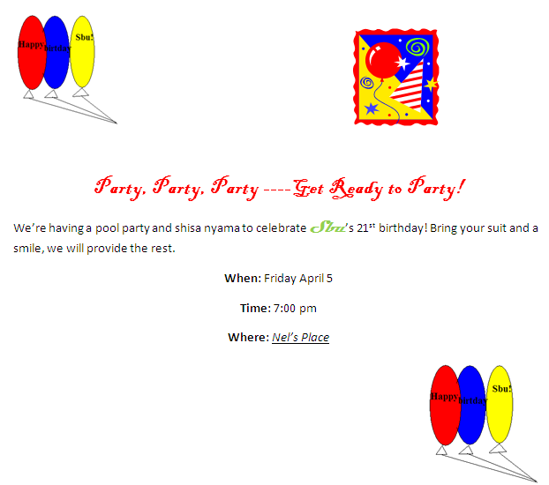

Task 3:

Setup Cloud Storage

There are different web sites providing you with this option: Google’s Gmail, YouTube, and Windows Live SkyDrive. We will use the last option.

- What is Windows Live?
It’s a collection of services and Web applications that you can use to help you be more productive both personally and professionally. For example, you can use Windows Live to send and receive e-mail, to chat with friends via instant messaging, to share photos, to create a blog, and to store and edit files using SkyDrive.
- What is Cloud Computing?
It refers to the process of working with files online in a Web browser. When you save files to SkyDrive on Windows Live, you are saving your files to an online location. SkyDrive is like having a personal hard drive in the cloud.
- What is SkyDrive?
It’s an online storage and filing sharing service
- Why use Windows Live and SkyDrive?
You can access additional storage for your files. You don’t have to worry about backing up your files to a memory stick or any storage device that could be lost or damaged. Another advantage is that you can access your file from anywhere as long as you have an Internet connection. You can also share your files with co-researchers by giving them permission to view and edit your files!
- What are Office Web Apps?
Office We Apps are versions of MS Word, Excel, PowerPoint, and OneNote that you can access from your SkyDrive. They do not include all the futures and functions, but you can access it from anywhere.
- How do SkyDrive and Office Web Apps work together?
You create a file in Office 2010 and then upload the file to your SkyDrive. You can then open the Office file saved to SkyDrive and edit it using your browser and the corresponding Office Web App.

Task 4:
- Log on the computer.
- Start menu: - click All programs, Microsoft Office then the Program of interest.
- Minimize, maximize and restore window: - click the two adjacent buttons at the top-right corner
- Display different tab on the ribbon: - click the other tabs on the ribbon to view their contents, i.e., file, home …..
- Minimize, display and restore the ribbon: - click the ribbon button just below the close (X) button – heart symbol
- Display and use shortcut menu: - right-click the quick access toolbar to display shortcut menu
- Customize the quick access toolbar: -any possible adjustments?
- Enter text in a document: - abcdefghijklmnopqrstuvwxyz……………………………….
- Create a folder in a USB: - click ’Open folder to view files’ , New folder button type CBIS01
- Create a folder within a folder: - double-click the icon for CBIS01, click new folder name it Word
- Expand a folder, scroll through a folder contents and collapse a folder: - double-click the folder
- Switch from one program to another: - use the program button or live preview on the taskbar
- Save a file in a folder: - click the Save button on the Quick Access Toolbar
- Minimize and restore a window: - click Minimize button or Windows Explorer button
- Quit an office program with one document open: - click Close then Save
- Create a new office document from the backstage view: - click File, New and Create
- Close the office file using the backstage view: - click File on the backstage view and then Close
- Open a recent office file using the backstage view: - click File, Recent tab, click file name
- Create a new blank office document from windows explorer: - click Windows explorer, open file
- Rename a file: - click Windows explorer, navigate, right-click the file name or use rename on shortcut
- Move a file: - navigate and drag
- Delete a file: - right-click to display shortcut menu, click Delete
- Open the help window-? in an office program: - click Office program’s Help button near the upper-right corner
- Move a window by dragging: - Drag the Window title bar
- Resize a window by dragging: - use a two headed arrow of the mouse to drag
- Obtain help using the ‘type words to search for’ text box: - type backstage, click Search button, click All Word
- Obtain help using the help links: - click the formatting link on the Help home page to display formatting page
- Obtain help using the help table of contents: - click the Home button, Show Table of Contents button
- Start windows help and support: - click Start button on the taskbar to display the Start menu.

Using Windows Help and Support
- How do you minimize all windows?
- What and where is the backstage view?
- What are the steps to add a toolbar to the taskbar?
- What wizard do you use to remove unwanted desktop icons?
- What is genuine windows?
- What steps are required to read the Microsoft Software Licence?

Task 5
- Microsoft Word 2010
- Word - Explore Window: - list eleven most important, outlining and visible parts of a word 2010 window.
- Word - Backstage View: - under which tab does backstage view fall?
- Word - Save Document: - which keyboard buttons do the function of saving a document?
- Word - Open Document : - which keyboard buttons do the function of opening a document?
- Word - Close Document : - which keyboard buttons do the function of closing a document?
- Word - Context Help: - what is it used for?
- Word - Activate the Insert tab, how many groups does Insert tab have?
- Word - How many commands does the Header & Footer group in your ribbon gallery have?
- Word - How do you minimize, display and restore the ribbon?
- Word - You have opened, and you are working with, many word windows. You want to display or show Windows 7 desktop, locate the desirable button.
- Word - What is does the ALT command on the keyboard do? What are Key tips?

Try by all means to navigate the Microsoft Word 2010 Window and locate all the following commands.

Editing Documents
- Word - Select Text
- Word - Delete Text
- Word - Move Text
- Word – Cut, Copy & Paste
- Word - Find & Replace
- Word - Spell Check
- Word - Zoom In-Out
- Word - Undo Changes
- Word – redo Changes
- Formatting Text
- Word - Setting Text Fonts
- Word - Text Decoration
- Word - Change Text Case
- Word - Change Text Color
- Word - Text Alignments
- Word - Indent Paragraphs
- Word - Create Bullets
- Word - Set Line Spacing
- Word - Borders and Shades
- Word - Set Tabs
- Word - Apply Formatting
- Formatting Pages
- Word - Adjust Margins
- Word - Header and Footer
- Word - Add Page Numbers
- Word - Insert Page Breaks
- Word - Insert Blank Page
- Word - Borders & Shades
- Advanced Operations
- Word - Quick Styles
- Word - Use Templates
- Word - Use Graphics
- Word - Auto Correction
- Word - Auto Formatting
- Word - Preview Documents
- Word - Printing Documents.

The following Exercises are from the prescribed book

MS Word Exercise 1:

Found Dog

Adorable, loving, friendly, well-behaved dog found early Friday morning, June 1, wandering on the bike trail at Filcher Park in Hampton Township.
Tan color with patches of white on his chest
Male, adult cocker spaniel
Green and silver collar with the name, Bailey, on the tag
If this is your lost dog, call 555-1029.



MS Word Exercise 2:

Annalisa Marino
Mr. Winters
English 101
April 4, 2017
Can You Find Me Now?
How is a Nintendo Wii game console able to determine the location of a Wii Remote while a player interacts with a game? The answer is triangulation, a process that determines the location of an object by measuring the angles from two or more fixed points.
Surveyors often use triangulation to measure distance. Starting at a known location and elevation, surveyors measure a length to create a base line and then use a theodolite to measure an angle to an unknown point from each side of the base line (Jains 30-48). The length of the base line and the two known angles allow a computer or person to determine the location of a third point.
Similarly, the Nintendo Wii game console uses triangulation to determine the location of a Wii Remote. A player places a sensor bar, which contains two infrared transmitters, near or on top of a television. While the player uses the Wii Remote, the Wii game console determines the remote’s location by calculating the distance and angles between the Wii Remote and the two transmitters on the sensor bar. Determining the location of a Wii Remote is relatively simple because the sensor bar contains only two fixed points: the transmitters.
A more complex application of triangulation occurs in a global positioning system (GPS). A GPS consists of one or more earth-based receivers that accept and analyze signals sent by satellites to determine a receiver’s geographic location. GPS receivers, found in handheld navigation devices and many vehicles, use triangulation to determine their location relative to at least three geostationary satellites. According to Sanders, the geostationary satellites are the fixed points in the triangulation formula (Understanding Satellites and Global Positioning Systems).
The next time you pass a surveyor, play a Nintendo Wii, or follow a route suggested by a vehicle’s navigation system, keep in mind that none of it might have been possible without the concept of triangulation.

Works Cited
Cordoba, Nicolas E., and Kara A. Sarkis. The Surveyor's Theodolite Formula. Orlando: Orange County Press, 2012. Print.
Jains, Malila. "How Surveyors Measure Distance and Calculate Angles." Today's Modern Surveyor Mar. 2012: 30-48. Print.
Sanders, Gregory B. Understanding Satellites and Global Positioning Systems. n.d. Course Technology. Web. 27 Feb. 2012.

MLA Documentation Style:
- 12-point Times New Roman
- Double Space
- Margins are set at 2.5 cm
- Use a header with your name and the page number in the right hand corner
- Your name, super visor, course, and date are on the left margin
- Have a title, centered
- Each paragraph is indented 1.27 cm ≈ 1.3 cm
- Works cited (parenthetical references) is used to refer to the bibliographical list of sources at the end of the paper.
- Can use foot notes
1. Change document settings (Styles, line and paragraph spacing)
2. Header: name and page number
3. Enter name and course information
4. Title
5. First line indent
6. Citations (Bibliography style, citations, create a source)
Example:
An angle to an unknown point from each side of the base line (Jains) .
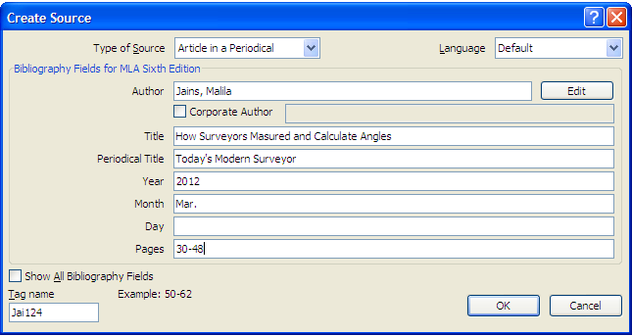

(Cordoba and Sarkis)
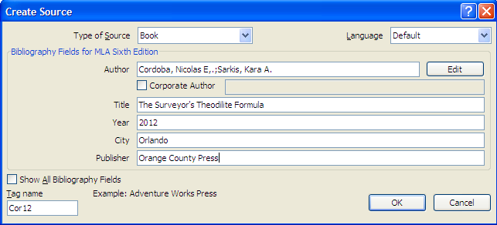
(Sanders)
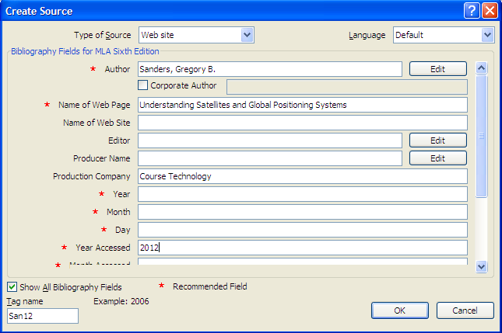
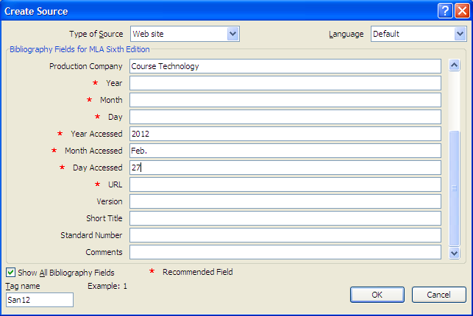
Footnote: Remember it must have the same format as the rest of the paper!!
………third point
- Right click in the footnote
- Select style
- Modify
- Change to Times Roman, 12, double space
- Click Format, select paragraph
- Click special box, select first line

MS Word Exercise 3:



Project: (This project carries a weight of 10% of the final mark.)

Preparing a Short Research Paper

Problem: YouTube is increasingly being used as a marketing platform. Read on this topic and write a one-and-a-half-page paper that summarizes the role this platform plays as a marketing tool.
Requirements/Guidelines:
- Research the topic in general
- Organize your ideas
- Write the first draft, referencing sources
- The paper must contain 350 - 400 words
- Create the list of sources
- Proofread and revise the paper
- The paper must be presented according to the MLA documentation style.
- Presentation to the class using Power Point.
- You must work in groups of two people.
Group Work: (Suggestions!)
Each team member is to write a minimum of 200 words summarizing his or her findings. Each team member also is to write at least one explanatory note and supply his or her reference for the works cited page. Then, the team should meet as a group to compose a research paper that includes all team members’ write-ups. Start by copying and pasting the text into a single document and then write an introduction, body and conclusion as a group. Use the concepts and techniques learned to format the paper according to the MLA documentation style.

PowerPoint Presentation
Why we have a slide show?
- You can deliver a dynamic, professional-looking message to an audience
- Enhances your oral presentation/effectively communicate your ideas
- Reinforce your message
- Help audience to retain the information presented.

The process of developing a presentation that communicates SPECIFIC information requires careful analysis and planning
- Why is the presentation needed?
- Analyze the intended audience
- Gather information about the TOPIC
- Decide what to include
- Design and style to successfully delivering the message
Topic: Energy conservation
1. It is easy being green
Green globe
Saving energy at home
Presented by BF Nel
Faucet
2. Make small changes to cut energy
Install low-flow faucets and shower heads
Cut water consumption in half
Appliances count for 20% of electric bill
Dishwasher
Buy ENERGY STAR qualified products
Run dishwasher, washing machine with full loads
Wash clothes in cold water
CFL
3. Use energy efficient lighting
4. Adjust your thermostats
Furnace
Furnace: 30 degrees
Geyser: 50 degrees
Water heater
5. Closing Slide/Conclusion
STEPS:
- Choose a THEME
- Create PP
- Insert pictures
- Transitions (special visual and audio effects to all slides: how it moves onto the screen)
- Animations (control the objects and text appearance on a slide)

End of learning guide

Cordoba and Sarkis state that electronic theodolites calculate angles automatically and then send the calculated angles to a computer for analysis (25).

