

MAIN EXAMINATIONS – OCTOBER 2017

FACULTY OF EDUCATION

DEPARTMENT OF MATHEMATICS, SCIENCE AND TECHNOLOGY

B.Ed. (Hons.): EDUCATIONAL COMPUTING
EEC591

DATE: 20 OCTOBER SESSION: 8H00 – 11H00

DURATION: 3 HOURS MARKS: 100

SUBMINIMUM: 40%
Internal Examiner
MR. B.F. NEL

Internal Moderator
MR. I.N. MTHEMBU

Moderator
MR. V.F.S. MUDAVANHU (UFS)

INSTRUCTIONS TO CANDIDATES

- Please ascertain that this question paper has ten (10) pages, and five (5) questions.
- Fill in your personal detail on top of THIS page.
- Important: This question paper is the property of the department and must be handed in with the answer sheet. Not doing so will earn you 0 Marks.
- Email your answer to: nelb@unizulu.ac.za
- The subject of the email is your student number and surname.

Question 1 [20 Marks]
(This question is implemented using MS Project)
The new elected minister of education wants the school departments to reach out to the community, offering eLearning to adults.
As HOD of your department, you have to develop a training course to implement this endeavor.
Usually it entails first to develop the material, constructing a manual, and the final stage will be to identify a trainer with an accompanying schedule.
You identify the following activities/tasks making up the above project:

TASK NO | DESCRIPTION | DURATION  (DAYS) | PREDECESSOR  TASK | RESOURCE
1 | Research
2 | Collect material
3 | Develop Notes
4 | Edit Notes
5 | Proof Read Notes
6 | Print Master
7 | Copy and Issue Manual
9 | Develop a trainer
10 | Develop Course Schedule
Fig. 1
You contact ABC Researchers who are specialist in eLearning to conduct the research, collect the material and to develop the notes. These task follow one another and their completion times are respectively, 4 days, 2 days and 4 days.

The tasks ‘Edit Notes’ and ‘Proof Reading” are conducted at the same time (parallel) by the local University’s Language Department (UZ) and will take 1 day each. They will commence after the task
‘Develop Notes’

The printing and issuing of the manual are done by Nashua Int. Copiers, taking 1 day each, and are done only after the proof reading was done. Issue of the Manual commences after the printing of the master.

Developing the trainer and the course schedule are done parallel, and only after the manuals were issued. These tasks will take 3- and 1 day respectively. These two task are done by the HOD.

The charging rates per hour (in Rand) is indicated in the table below:

Resource  Name | Rate | Overtime  Rate
ABC Researchers | 500.50 | 600.00
UZ | 350.00 | 450.00
Nashua Copiers | 220.50 | 405.00
HOD | 200.00 | 0.00

Complete the above table, Fig. 1, representing the task lists or WBS to assist you in the next question. Analyze the facts carefully to determine which tasks are concurrent and which ones depend on other tasks. No marks are allocated for this!!
  - Identify three overview tasks (three main sub-tasks) to the project task, and develop a Gant Chart with resources, using MS Project. The project must start on the 15th January 2018. (10)
  - Did you encounter any problems, like meeting ROG: Red Over-allocation Guy?
Or the Burning man?
What steps did you take to solve this problem? (4)

  - Create a milestone, and explain its significance. (2)

  - What is the total duration and cost of the project? (2)
Duration:

Cost:

  - What is the critical path for this project? (2)

Question 2 [26 Marks]
As your school’s IT teacher/specialist, you have to determine the financial viability of developing a Training Course. One of the first task was to develop a project iteration schedule and then/now to draw–up a NPV spreadsheet to perform a cost/benefit analysis.

The estimated initial development cost:
Expense Category | Amount
Course Development | R 60 000.00
Equipment/Install (laptops and smart phones) | R 50 000.00
Facilities | R 10 000.00
Total | R 120 000.00

When the system becomes operational after a one-year development period, operational costs will be R 10 000 during each year of the system’s four-year “useful” life.
The system will produce benefits of R 50 000 in the first year of operation, and this figure will increase by a compounded 10% each year.
Note: Marks are allocated for using an Excel function to calculate the subsequent benefits.
OPEN Sheet 1 and use the above information and MS Excel to:

- Develop a worksheet to determine the NPV over a four year period, calculated at 8% pa compounded yearly: (Discount factors are already included) (15)

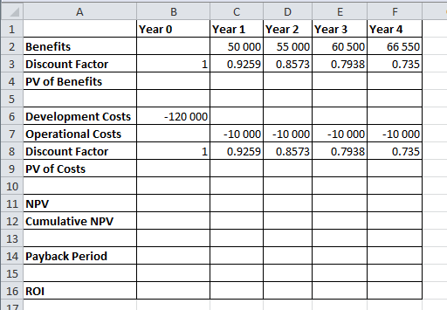

- Use the worksheet information and determine the payback period. (3)
The formula for linear interpolation is
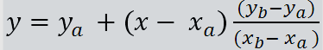

- Use the worksheet information and determine the ROI. (3)
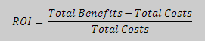

- Draw a scatter chart of year versus cumulative NPV, to give a rough estimate of the payback period, confirming your results in (b). The graph must have a proper title and labels for the axes. (5)

Question 3 [28 Marks]

Open Sheet 2 and prepare an amortization schedule for a debt of R 1 000 000 bearing interest at 6% pa, compounded monthly, if the debt is amortized by a series of monthly payments over 15 years, starting on the 1st of January 2018:

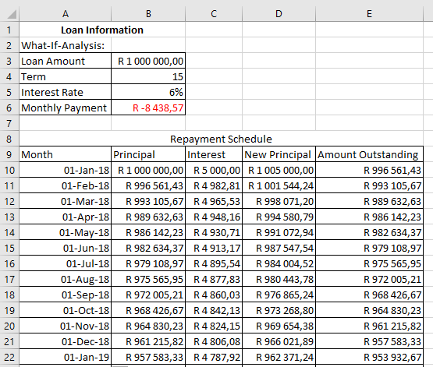

Formulae:
Interest = Principal x Interest Rate; New Principal = Principal + Interest;
Outstanding Amount = New Principal - Payment

- Write down the formula for the payment calculation. (6)

- What is the outstanding amount on the 1st of December 2026? (10)

- Consider the following What-If Analysis: What is the outstanding amount on the 1st of December 2026, if the Debt is changed to R 2 000 000, before the first payment is due? (3)

- Revert to the original debt value of R 1 000 000, and use Goal Seek to determine the new loan amount, if the client prefer to pay a monthly payment of R 16 000. (4)

- Revert to the original debt value of R 1 000 000. Create an interactive toolbar to change the years between 10 and 20 (inclusive) in steps of 1 year. (5)

Question 4 [11 Marks]
The following is a term mark schedule for your class:

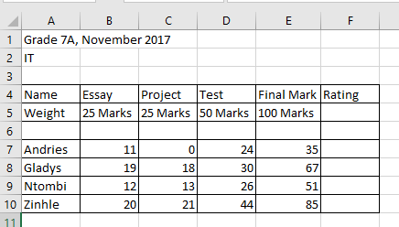
Create the above spread (MS Excel) sheet using Sheet 3. Do then the following calculations and use the appropriate functions:
- From cells E7 to E10 compute the total/final mark for each pupil. (3)
- Convert the final mark into a rating using the VLOOKUP function. Use the rating table below: (7)
RATING | PERCENTAGE
1 | 0 – 29%
2 | 30 – 44%
3 | 45 – 49%
4 | 50 – 59%
5 | 60 – 69%
6 | 70 – 79%
7 | 80 – 100%

- Arrange or sort the list numerically, ascending, according to ratings. (1)

Question 5 [15 Marks]
This question has to do with the determination of the root of a number a, (say 68), using Excel. This is an application problem we never did before. You are welcome to use the Help facility or the Internet.

- Use sheet 4, with the following layout: (3)

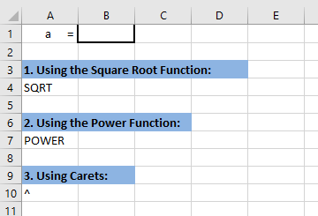
Enter 68 in cell B1, and calculate its root value using the different functions, as indicated, in cells B4, B7 and B10. Your functions MUST reference B1.

- Another method is Newton’s Method: this is a classic algorithm that one can use to determine the square root of a number. (12)

The algorithm starts with some guess x₁ > 0 and computes the sequence of improved guesses:

$$x_{n+1}=\frac{x_{n}}{2}+ \frac{a}{2x_{n}}$$

Where
a is the number we want the square root to be calculated (in our case 68),
x_{n} is our guessed value and
x_{n+1} is the new calculated guessed value

In the next iteration x_{n+1} will becomes the guessed value x_{n}; and so the process will repeat itself.

Open sheet 5, and use the following layout:

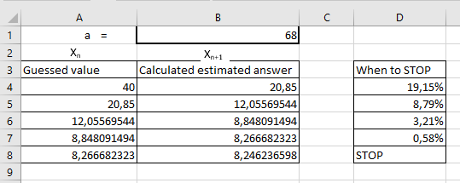
NOTE: So our first guess was 40. We feed it into the formula, only to get a result of 20,85. This becomes our new guessed value! Hope you are getting it!!

- Type your formula in cell B4. Make sure you refer to B1 (the root value we like to calculate) and A4 (your first guessed value). The formula must be written in such a way, that it can be copied and dragged easily! (6)
- This series will eventually converge to an approximation of the square root we wanted. We will use this convergence also now to STOP our search: this means that when the difference between two consecutive guesses are less than 0,5%, you must stop calculating the root value:
You must create an IF statement to print STOP when this condition is reached. While the condition is NOT reached, it must print the percentage difference between the two consecutive guesses.
Create a column heading (I called it ‘When to Stop’), representing this calculation. (6)

Total: 100 Marks

************************************** The End ********************************

