

FORMATIVE ASSESSMENT 1 – SEPTEMBER 2017

FACULTY OF COMMERCE, ADMINISTRATION AND LAW

DEPARTMENT OF ACCOUNTING AND AUDITING

CMIS312- Information System Management 3D
(Accounting Information Systems)

DATE: 5 SEPTEMBER 2017 SESSION: 11h30 – 14h30

DURATION: 3 HOURS MARKS: 120

Internal Examiner
Mr. B.F. Nel
Internal Moderator
Mr. I.N. Mthembu
Moderator
Mr. F. Mudavanhu (Department of Computer Science, UFS)

INSTRUCTIONS TO CANDIDATES

- Please ascertain that this paper has six (6) pages, and 3 Questions
- Question 2 and 3 are answered on the question paper.
- Answer must be emailed to nelb@unizulu.ac.za.
- Attached on page 6 are all the FC symbols.
- Fill in your personal detail on top of THIS page.

Question 1 [102 Marks]
Mr. Nene is running his car repair shop for some years now, but find many inconsistencies or inefficiencies, especially on the accounts side, and besides, business start to boom lately that just compound the problems of control. He believes that by analyzing the processes he would maybe uncover some steps helping him to understand the system or can improve the system. He called you as an analyst to determine the flow of data, and to assist in completely automate his repair shop’s system.
The current system is described as follows:

Motor vehicles come to the workshop for repairs.
The mechanic assistant keys a car history document, containing the car’s VIN number and the reason(s) for repair into the computer. The computer records the input in the car history file.
The supervisor would make an assessment of the repair needed, download an inspection document from the inspection file, fills (keys) it in, and upload the file to the inspection file. The supervisor will access the parts file, selects the parts no (id) needed to fix the car, save it back onto the parts file, and print a copy. He will give this copy to the mechanic to collect it from the store room.
The mechanic and his assistant will now repair the car. Based on the work done on the car, the mechanic will complete a time card (hard copy) and file it in the file-cabinet under the billing file.
When the repair had been done, the supervisor will download the parts info from the parts file for that vehicle, take the time card from the billing file and the inspection report from the inspection file to calculate the labor costs and total costs to create a bill. This bill will be given to the customer.

a) Use the above narrative and create an Entity and Activity Table: (35)
Marks will be allocated to the steps or process you followed to arrive at the table.
(Use the layout below as headings)

Entities Para. Line No. Activity Info Process: Yes/No

b) Use MS Visio and draw a context diagram based on the above table. (4)

c) Re-draw the above Entity-Activity Table, but with the non-information processes removed. Divide the activities into processes. (4)

d) Use MS Visio and draw a level 0 DFD based on c). (15)

e) Use MS Visio and draw a System Flow Chart. (44)

Question 2 [8 Marks]
There are DFD diagramming errors on the DFD diagram below. Indicate them on the diagram and explain the type of error:

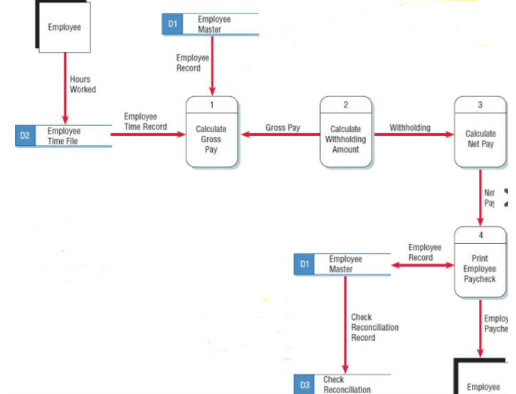

Question 3 [10 Marks]
Below are segments from system flowcharts:

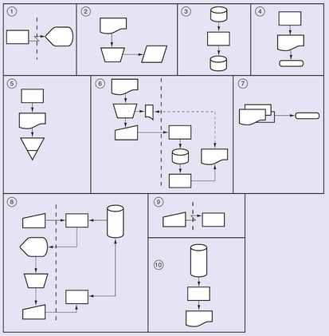

Complete the table on the next page, matching each flowchart above with ONE of the routines below:

- Two documents are sent to an external entity.
- Data on source documents are keyed to an offline disk.
- Programmed edits are performed on key input, the data entry clerk investigates exceptions and keys in corrections, and then data on the disk are updated.
- Inputs stored on two magnetic disks are merged.
- The computer prepares a report that is sent to an external entity.
- Output is provided to a display device at a remote location.
- A batch total of input documents is compared to the total reflected on an error and summary report produced after the documents were recorded.
- Data are keyed from a remote location.
- Data on a magnetic tape are printed during an offline operation.
- Data stored on a disk are sorted and placed on another disk.
- A report is printed from the contents of a disk.
- Documents are manually posted to a paper ledger.
- Magnetic tape input is used to update master data kept on a disk.
- A printed output document is filed.
Complete the table below:

Flowchart Number | Matching Routine Letter
1
2
3
4
5
6
7
8
9
10

Total: 120 Marks

