University of Zululand
Website: http://www.unizulu.ac.za

Private Bag X1001
3886 KwaDlangezwa

Faculty of Commerce
Administration & Law
Department of Accounting and Auditing

Module Title | Information Systems Management 3B: Systems Design
Module Code | CMIS302
Programme in which the module is offered | National Higher Degree: B.Com (Management Information Systems).
Year of offering | 2017
SAQA Credits | 15
NQF level | 7
Name of Lecturer / Lecturers | Mr BF Nel

“The difference between “theory” and “practice” is that in theory there is no difference between theory and practice, but in practice, there is.”
Prof. Van De Snepscheut, Caltech

Date: 3 July 2017

Dear Student

Welcome as learners, to the Information Systems course: Analysis and Design of IS. This is a continuation of CMIS301, where we introduced the topics of analysis.

We would like to invite you to use the lecturer as facilitator to develop your knowledge in this subject to the maximum. In order to attain success in this subject, your own contribution is important. It is important that you realize that it is your responsibility to prepare for classes and to initiate class discussions. If your attitude towards your study is correct, it will lead to enthusiasm and success will inevitably await you in your future career!

So CMIS302 really just builds on CMIS301, where we substantiate the theory with
MS Visio. We will continue with the object oriented approach with UML, where MS Visio still plays a cardinal role in our development.

Topics that will be covered:
- Design activities, focusing on the environment and user/system interfaces
- System development, using the SDLC and agile development
- Project management
- Object Oriented design principles and use case realization
- MS Visio
- Storyboard
- App Inventor
- Advance Excel
Purpose of the learning guide

This learning guide serves as an instrument of preparation for the learner. It enables you to plan your studies and to follow the completion of the curriculum framework. For the theory component it goes without say the student has to do the Review Questions at the end of each chapter. Time will be spent on the Problem and Exercises.

The content of this learning guide must not be regarded as complete. The accumulation of knowledge and insight, as well as the achievement of specific goals, is the learner’s primary responsibility. The learning process will be facilitated within the academic framework with the learning outcomes. The learner should therefore know which learning outcomes must be achieved after each session and what the learner will have to give account of at the end of the module.

Lecturer’s expectations

As the facilitator my expectations from you, as a learner, is to work hard, read the relevant literature before class and diligently do your homework and assignments. Prepare well and timeously for your tests and hand in assignments of a good quality on time. Be the best student you can be.

Lecturer’s contact details

Office no: D-210
Office telephone: 035 902 6187
E-mail address: nelb@unizulu.ac.za
WhatsApp: 082 482 7547
Department: Accounting and Auditing

TABLE OF CONTENTS
Page
- Definition of terms 3
- Generic outcomes 4
- Module purpose 4
- Module outcomes 5
- Topics with scheduling 6
- Notional hours 6
- Consultation times 6
- Mode of delivery 6
- Assessment procedures 6
- Assessment criteria 7
- Guidelines for presenting assignments 8
- Reference style 8
- Prescribed readings, and additional (recommended) readings 8
- Materials needed for the module 9
- Plagiarism 9
- Detailed outcomes 9 – 14

Appendices:
- Cost benefit Analysis 15 - 25
- Project Management 26 – 27

- DEFINITION OF TERMS

- Learner/study guide: A learner/study guide helps in organising lecture notes and textbook material so that students can increase their comprehension and memory of large amounts of information. Specific outcomes on topics covered, the summary of content, as well as revision questions are included.

- Tutorial: A tutorial is an interactive method of transferring knowledge in the learning process. A tutorial seeks to teach by example and supply the information to complete a certain task.

- Practical: A practical is a lesson in which theories and procedures learned are applied to the actual making or doing of something.

- Formative assessment: The goal of formative assessment is develop and monitor student learning to provide on-going feedback that can be used by lecturers to improve their teaching and by students to improve their learning.

- Summative assessment: The goal of summative assessment is to evaluate student learning at the end of an instructional unit by comparing it against some standard or benchmark.

2. GENERIC OUTCOMES

After working through and studying this module the learner should have grown and understand the following concepts:

- Terminology. The student will be able to explain the meaning of terms used to describe common techniques and concepts in information system analysis and design.

- Skill. The student will successfully use MS Visio and AppInventor in the design of systems.

- Advanced Information Systems Concepts. The student will be able to describe the system requirements in the latest UML language, applying OO concepts. These concepts include use cases, event decomposition, domain and class models, activity diagrams and system sequence diagrams. Client/server and three layer design architecture concepts will be developed.

- Systems Development. The students will be involved in a small‐scale class development project and gain experience working in teams.

- Behavioral and Organizational Issues. The student will be able to identify and suggest appropriate responses to managerial and organizational issues stemming from development, implementation, and use of computer‐based ISs.

- International Issues. The student will recognize the reality of implementing international ISs, including economic and cultural differences.

- Social and Ethical Issues. The student will understand the major social and ethical issues involved in the development and use of information technology.

- MODULE PURPOSE
This program is intended for business students, and no previous knowledge of programming is required. This program is a hands-on approach following the case study of RMO in the prescribed book, and also an in-class project of a “Community Board of Realtors” system, applying all the knowledge gain in CMIS301and more!

This idea of learning by doing has long been recognized as an optimal form of education. The key is to engage the brain with practical tasks! So the course is really driven by an old model: KIT. This acronym stands for Knowledge, Insight and Technology. Knowledge was mainly gain in CMIS301, and the focus shifts now to Insight and Technology.
Another focus point will be team building! Meaning students will perform tasks, exercises and projects in teams. It is most important that students get experience working in teams, building an information system. In the real world, information systems are almost invariably developed by teams, and I believe that we short-change our students if we do not give them this experience. The size of the team is critical, but from an academic point we can only allow a team to consist of two students, maximum three students.

4. MODULE OUTCOMES

After working through and studying this module the learner should be able to:
- Apply design activities, focusing on the environment and user/system interfaces
- To develop a system, using the SDLC and agile development paradigm
- To apply project management skills
- Understand Object Oriented design principles and use case realization
- Apply MS Visio
- Apply App Inventor
5. TOPICS WITH SCHEDULING
The chapters below refer to the prescribed book, covering the theory component:
Week | Theory
2, 3 | Chapter 6
4, 5 | Chapter 7
6, 7 | Chapter 8
8, 9 | Chapter 9
10, 11 | Chapter 10
12, 13 | Chapter 11

The content of the instructional offering is summarized as follows:

Theory
- Design activities, focusing on the environment and user/system interfaces
- System development, using the SDLC and agile development
- Project management
- Object Oriented design principles and use case realization

Practical

- MS Visio: drawing diagrams for all the UML models
- MS Project: Gant – and Pert-Charts
- App Inventor for interface design
- Excel applied to cost benefit analysis

6. NOTIONAL HOURS
The number of hours that this module has been allocated on the timetable is 5 x 45 minute periods. 2 x 45 minute will be allocated to the discussion of theoretical concepts, and 3 x 45 minutes will be allocated to hands-on work. Notional learning hours are hours that are used for the learning activities and assessment of the module such as lectures, tutorials, practicals, presentations, independent study etc. The number of notional hours for this module accumulates to 150:

Contact Sessions: 52 Hours=30 Hrs (Formal lectures) + 22 Hrs Tuts
Assignments: 48 Hours (±8 hours per chapter)
Project: 6 Hours
Theory Tests Preparation: 38 Hours (=contact sessions: 2x19Hrs)
Assessments: 6 Hours
Total: 150 Hours

7. CONSULTATION TIMES

As for CMIS301, we as a class use WhatsApp:
Every day, 8h00 – 20h00

You are also most welcome to make formal appointments to discuss the work, either using eMail or talk to me in class!

8. MODE OF DELIVERY

The mode of delivery of this module consists of theory, practicals, and assignments.

9. ASSESSMENT PROCEDURES

Assessment is an on-going evaluation process aimed at understanding and improving student learning by measuring the learning outcomes the students may have to be achieved. Students will have a clear idea of why they are being assessed in the way they are. Finally, students will be helped to understand what they need to be able to do to get higher grades in their modules.

10. ASSESSMENT CRITERIA

The assessment criteria must arise from, and be linked to, the intended outcomes. You, as students, will be informed about the way in which you will be assessed. This means that you will be told what knowledge, skills and outcomes need to be acquired in order to achieve the outcomes.

Students will be assessed on:
- Assignments; will take the form of class discussions
- Assessments: Practical and Theory
- Examination

While preparing for assessments, you must ensure that you meet all the outcomes and assessment criteria as stated in each learning unit.

Due Performed (DP) requirement:

A student will NOT be permitted to write the final examination in a module if he/she fails to satisfy the minimum DP requirements. This requirement states that a student must achieve a DP of 40%. The DP will comprise tests, class work and assignments – at the discretion of the lecturer.

10.1. FORMATIVE ASSESSMENT (DURING THE SEMESTER)

Formative assessment takes place during the process of teaching and learning with the purpose of developing the learners’ abilities. Formative assessment will occur in the form of formal tests, class work, and assignments.

If any of these are missed, marks of zero (0) will be awarded unless a valid medical certificate or reason is handed to me as soon as possible. Alternative arrangements will be made at the discretion of the lecturer.

10.2 SUMMATIVE ASSESSMENT (FINAL EXAMINATION)

Summative assessment is undertaken to make judgment about the learners’ achievement and is carried out at the end of the learning programme. A three hour examination will be written at the end the semester covering the learning outcomes as set out in the learning guide. The relevant assessment criterion for this module is as follows:

Course Mark:  Theory test – 25 %  Practical test – 25 %  Assignments take the form of Class discussions – 0% | 50 %
Examination | 50 %
Total | 100 %

A final mark of 50% is necessary in order to pass this module. Obtaining between 40 % and 48 % in the main examination qualifies a student to write the supplementary examination.

11. GUIDELINES FOR PRESENTING ASSIGNMENTS

The following guidelines should be followed when submitting a typed assignment:

You are IS majors, and has a free hand to this! ‘Calibri’ is the official font chosen by the University, 11 Point font, 1.5 line spacing. Sizes of pages and margins can be communicated to the student by the lecturer. Use the university approved assignment cover page.

12. REFERENCING STYLE

Both Harvard and APA referencing styles can be used in the writing of tasks. Visit https://www.staffs.ac.uk/assets/harvard_quick_guide_tcm44-47797 and www.apastyle.org

13. LITERATURE

Prescribed:

JW Satzinger, RB Jackson and SD Burd, Introduction to Systems Analysis & Design, an Agile, Iterative Approach , Cengage, 6th Edition 2012 (ISBN 0619216433)

Additional Reading:

- Requirements Analysis and System Design, by LA Maciaszek, 3rd Ed. 2007.
(ISBN 9780321440365)
- Use Case Driven Object Modelling with UML Theory and Practise, by D Rosenberg and M Stephens, 2007 (ISBN 9781590597743)
- Applying UML and Patterns, An introduction to O-O Analysis and Design and Iterative Development, C Larman, 3rd Ed. 2005 (ISBN 0131489062)
- UML 2 and the Unified Process, by J Arlow & I Neustadt, 2nd Edition (ISBN 0321321278)
- Object-Oriented Analysis and Design with UML, by RV Stumpf and LC Teague, 2005 (ISBN 131434063)
- Understanding Object-Oriented Programming with Java, by T Budd (ISBN 020161273739)
- Introduction to Object-Oriented Analysis and Design, with UML and UP, by SR Schach(ISBN 0071215107)

The beauty of this is that ALL the above books are in our UZ Library…..enjoy the reading!!

14. MATERIALS NEEDED FOR THE MODULE

It will be an added advantage if you can have a personal PC/Laptop. The computer work is advanced, are very involved. We do not have a dedicated computer lab, and I cannot guarantee extra lab time especially set aside for this course. We usually negotiate for a lab for ONLY use by CMIS302. IT IS OFF UTMOST IMPORTANCE THAT YOU WORK ON YOUR COMPUTER SKILLS: MS Word and Excel
15. PLAGIARISM STATEMENT
Plagiarism is an act of fraud. It involves both stealing someone else's work without acknowledging the owner. Plagiarism may take place in different ways and these are:
- To submit an essay written in whole or in parts by another student as if it were my own.
- To download an essay from the internet, then quote or paraphrase from it, in whole or in part, without acknowledging the original source.
- To restate a phrase verbatim from another writer without acknowledging the source.
- To paraphrase part of another writer's work without acknowledging the source.
- To reproduce the substance of another writer's argument without acknowledging the source.
- To take work originally done for ones lecturer’s assignment and re-submit it to another lecturer.
- To cheat on tests or quizzes through the use, hidden notes, viewing another student's paper, revealing the answers on my own paper to another student through verbal or textual communication, sign language, or other means of storing and communicating information--including electronic devices, recording devices, cellular telephones, headsets, and portable computers.
- To copy another student's homework and submit the work as if it were the product of your own.

Therefore, the university views plagiarism in a very serious light. The consequences for committing any of the previous acts of academic dishonesty can include, but not limited to these: failing the assignment, failing the entire module, and even expulsion from the university.

16. DETAILED OUTCOMES:

Chapter 6:
Essentials of Design and the Design Activities

So far, CMIS301, the discussion was about system analysis, or ‘understanding the user’s requirements’, now we shift to design or ‘the solution’. In this chapter the discussion is briefly about the environment, one of the first design activities.

This chapter will focus on:
- The elements of design
- Inputs and Outputs for Systems Design
- Design activities
- Design the Environment

Specific Outcomes:
At the end of this chapter you will
- Describe the difference between system analysis and design
- Explain each major design activity
- Describe the major hardware and network environment options
- Describe the various hosting services available

Chapter 7:
Designing the user and system Interface

This chapter addresses two types of system interfaces: user interfaces and system interfaces. User interfaces are those inputs and outputs that involve a user to enter or review information. System inputs and outputs are either those that go directly to another system without any user involvement, or those that only minimally involve users. For example, the printing and mailing of customer bills is considered a system output because even though it is eventually going to a person, the printing, folding, and mailing is primarily done as part of an automated process.
User-centered design is an important concept that is addressed early in the chapter. There are various metaphors of how a user accesses and interacts with an automated system. Considering these metaphors assists analysts to define and describe the user interface more effectively. Such metaphors as direct manipulation metaphor, desktop metaphor, document metaphor, and dialog metaphor all describe the user interface in slightly different terms and help in understanding and specifying an effective user interface.

This chapter will focus on:
- User and system interfaces
- Understanding the user interface
- User-interface design concepts
- The transition from analysis to user-interface design
- User-interface design
- Identifying system interfaces, inputs and outputs.

Specific Outcomes:
After reading this chapter, the student should be able to:
- Describe the difference between user interfaces and system interfaces
- Describe the historical development of the field of human-computer interaction (HCI)
- Discuss how visibility and affordance affect usability
- Describe user-interface guidelines that apply to all types of user-interface types and additional guidelines specific to Web pages and mobile applications
- Create storyboards to show the sequence of forms used in a dialog
- Discuss examples of system interfaces found in information systems
- Define system inputs and outputs based on the requirements of the application program
- Design printed and on-screen reports appropriate for recipients

Chapter 8:
Approaches to System Development

There are two closely related yet independent concepts in this chapter. The first important concept is that there are two types of Systems Development Life Cycle approaches—a predictive approach and an adaptive approach. The second important concept is that there are two types of development methodologies—a structured approach and an object-oriented approach. These are two separate concepts. Projects can be any mix of these two approaches, the approach to the life cycle and the approach to the methodology—predictive with structured, predictive with object-oriented, adaptive with structured, or adaptive with object-oriented.
The chapter first presents and explains the differences in the life cycle approach—the predictive and the adaptive approaches. These two approaches are really a continuum and any give project may have elements of both approaches. The predictive approach to the SDLC is used for projects that are well understood and low risk. The adaptive approach to the SDLC is used for projects that are not well understood and are higher risk. Adaptive SDLCs are more iterative and allow the project team to adapt the project to changing circumstances.
Finally the chapter concludes with a discussion of the Agile philosophy and Agile modeling principles. Students should understand that Agile philosophy recognizes that most users do not understand the complexities of business processes and supporting software and therefore most projects must be flexible and agile. Agile modeling has basic principles to encourage developers to use modeling as a means to the end product (working software), and not an end in and of itself.

This chapter will focus on:
- The system development life cycle
- The support phase
- Methodologies, Models, Tools and Techniques
- Two approaches to software construction and modeling
- Agile development

Specific Outcomes:
At the end of this chapter you will
- Compare the underlying assumptions and uses of a predictive and an adaptive system development life cycle (SDLC)
- Describe the key activities and tasks of information system support
- Explain what comprises a system development methodology—the SDLC as well as models, tools, and techniques
- Describe the two overall approaches used for software construction and modeling: the structured approach and the object-oriented approach
- Describe the key features of Agile development

Chapter 9:
Project planning and project management
This chapter has three major themes.
A review of basic project management principles and the PMBOK
A discussion of the activities of Core Process one: Identify the problem and obtain approval
A discussion of the activities of Core Process two: Plan and monitor the project
Project management can be taught in two different ways, either from a conceptual point of view, or from a list of skills and activities point of view. The first section on the principles of project management, as well as the discussion of the PMBOK in Online Chapter C, present a conceptual foundation of project management principles.
Skills and activities are taught through explanations of the first two Core Processes.

This chapter will focus on:
- Principles of project management
- Activities of core process 1: Identify the problem and obtain approval
- Activities of core process 2: Plan and monitor the project
Specific Outcomes:
At the end of this chapter you will
- Describe the factors that cause a software development project to succeed or fail
- Describe the responsibilities of a project manager
- Describe the knowledge areas in the project management body of knowledge (PMBOK)
- Describe the Agile approach to the project management knowledge areas
- Explain the activities required to get a project approved (Core Process 1)
- Explain the activities required to plan and monitor a project (Core Process 2)

Chapter 10:
Object-Oriented Design: Principles
First the basic idea of what object-oriented design is and why it is useful is introduced. The second topic within the chapter teaches architectural or high-level design. The later part of the chapter introduces and teaches concepts related to detailed design. After introducing the concepts of design, the chapter teaches about design class diagrams.

A method of actually doing detailed design is presented via the concepts of Class-Responsibility-Collaboration or CRC cards. The use of CRC cards is a popular method of doing detailed design, and works quite well for simple systems. The chapter ends with a discussion of principles that determine whether a detailed design is “good” according to metrics of design quality.

This chapter will focus on:
- Object-Oriented design: bridging from analysis to implementation
- OO architectural design
- Fundamental principles of OO detail design
- Design classes and the design class diagram
- Detail design with CRC cards
- Fundamental detailed design principles

Specific Outcomes:
At the end of this chapter you will
- Explain the purpose and objectives of object-oriented design
- Develop UML component diagrams
- Develop design class diagrams
- Use CRC cards to define class responsibilities and collaborations
- Explain some of the fundamental principles of object-oriented design

Chapter 11:
Object-Oriented Design: Use Case Realization

The purpose of this chapter is to provide in-depth knowledge and skills on how to do low-level design of complex systems.

The primary focus of this chapter is on developing detailed object-oriented design models, which programmers then use to code the system. The two most important models that must be developed are design class diagrams and interaction diagrams, either sequence diagrams or communication diagrams.

Design class diagrams are developed for each layer (domain, view, and data access) of three-layer design to extend the domain model that was developed during analysis.

Interaction diagrams extend the system sequence diagrams, also developed during analysis. This chapter also discusses how to associate classes into package diagrams to show relationships and dependencies.

Finally, the chapter presents principles of good design as defined by design templates or design patterns. Design patterns is an important topic and a broad area – especially for those that begin their careers as programmers. Most of the development frameworks, e.g. Struts for Java, Zend for PHP, Visual Studio for .NET, are based on the Model-View-Controller (MVC) pattern
This chapter will focus on:
- Detailed design of multilayer systems
- Use case realization with sequence diagrams
- Designing with communication diagrams
- Updating and packing the design classes
- Design patterns

Specific Outcomes:
At the end of this chapter you will
- Explain the different types of objects and layers in a design
- Develop sequence diagrams for use case realization
- Develop communication diagrams for detailed design
- Develop updated design class diagrams
- Develop multilayer subsystem packages
- Explain design patterns and recognize various specific patterns

ASSESSMENT METHODS/STANDARDS:

After completion of each chapter, learners will demonstrate their competence by doing assignments related to the outcomes. These assignments will be selected from the problems at the end of a chapter, and will be given in class. It can happen that we will do ALL the problems!

Theory: The theory test will cover these outcomes (not ALL!) but also extra problems to test insight. Fairness is important, and do remember that we have an external moderator also keeping an eye what we doing.
Let me give you back ground to what is expected from a final year student at university level:

Too understand the approach in this course you have to understand one of the education models we applied to this course: Blooms taxonomy theory. Evaluate your progress in “climbing a ladder” matching the type of questions you have to answer! A challenging question at our level will be to force you to combine knowledge from chapter 1, with that of chapter 4, with that of chapter 7…get the picture!! Scary….? No it is a challenge!

During class, theory and practicals, I will match it to the diagram below:

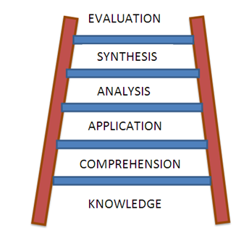
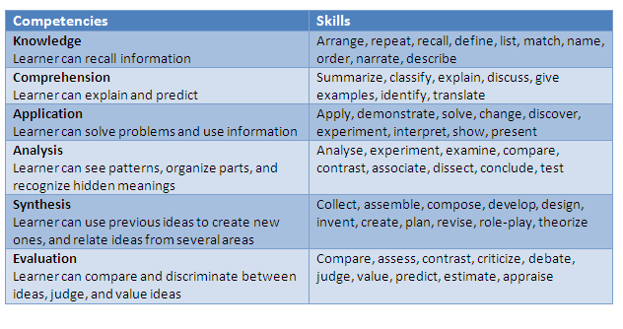

“Learning is always rebellion……Every bit of new truth discovered, is revolutionary to what was believed before”
Margaret Lee Runbeck

Practical: Hands-on training is from the utmost importance. To be competent in IS you must be able to SHOW what you can do! So practicals will link up with the case studies we doing and absolute testing your abilities. You will apply MS Visio, Project management and App Inventor to unique problems.

Examination: See ‘Practical’ above!!

APPENDIX 1:

Cost-Benefit Analysis using Excel 2010
When organizations evaluate the financial feasibility of investment decisions, the time value of money is an essential consideration. This is particularly true when a project involves cash flow patterns which extend over a number of years. We will discuss Discounted Cash Flow (DCF), Net Present Value (NPV) and Payback Analysis as tools to assess the profitability of a project.
- DCF
DCF is most often used to describe the calculation whereby the rate of interest is found which equates the present value of the negative and positive cash flows from a particular investment, where the negative flows have to do with costs and the positive flows are anticipated profits from the investment. Formally this is solving the equation
$$A= \frac{C_{1}}{1+r}+\frac{C_{2}}{{(1+r)}^{2}}+…+ \frac{C_{n}}{{(1+r)}^{n}}$$
Where A is the capital outlay;
C₁, C₂, …… are the end-of-year cash flows arising as a result of the outlay
r is the rate if interest for which the equation is solved.
  - Internal Rate of Return (IRR)
This is the rate which is found as the solution of a DCF calculation. It is thus the rate which is specifically relevant to the expected outcome of the project being considered and thus is internal to it as opposed to external rates of return such as money market yields.

Though there is no formal convention this rate is usually designated as r.
  - Example
A project is being considered by a company the details of which are:
Capital cost of R 1000.00
Positive cash flows of R 500, 600 and 400 respectively at the end of year 1, 2 and 3.
What is the IRR for this investment?
Capital cost End of year cash flows
1 2 3
R 1000 R 500 R 600 R 400

OPEN Excel, and set up the outlay as follows:
(Note: To find the IRR function, click on ‘Insert Function’, select as category ‘Financial’, and select ‘IRR’.)
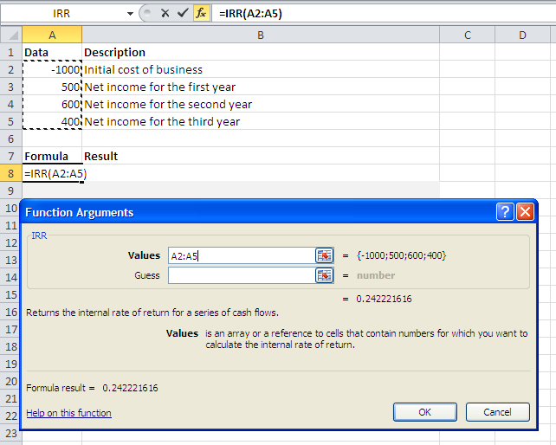
Although the answer is 24.22%, it is unlikely that the cost and cash flow estimates would justify such spurious accuracy and the IRR can be taken as 24%.
4.3 Exercise
A company is considering two mutual exclusive projects, the details of which are as follows:
Capital cost End of year cash flows
1 2 3
Project A R 1000 R 100 R 1000 R 653
Project B R 1000 R 600 R 600 R 374

Show that the DCF returns are:
Project A 28%
Project B 29%
- NPV
This method is an alternative to DCF whereby a rate of return is assumed, (e.g. a company’s cost of capital), and the cash flows are discounted to the time that the initial capital outlay was incurred. The net difference between initial capital outlay and the discounted cash flow is a commuted measure of the project’s expected contribution to profit, if positive.

5.1 Example
Using the same data as Example 1.2 the company is prepared to consider any investment yielding 20% or over as this rate is considered to represent a reasonable rate of return.
The present value of the cash flow is
$$PV= \frac{500}{1.2}+ \frac{600}{{1.2}^{2}}+\frac{400}{{1.2}^{3}}$$
But we will use Excel to solve the above, using the NPV function!!
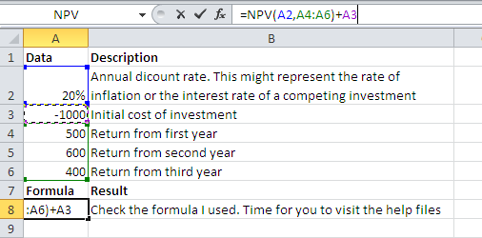
When executing this formula, you will find that the NPV = R 65, which can represent the commuted value of the profit which will accrue in the addition to the acceptable level of IRR.
5.3 Exercise
Use the data of exercise 1.2 and calculate the NPV’s of the two projects if the company is prepared to consider all projects that have a return in excess of 20%.
Capital cost End of year cash flows
1 2 3
Project A R 1000 R 100 R 1000 R 653
Project B R 1000 R 600 R 600 R 374

Show that the NPV’s are;
Project A R156
Project B R133

5.4 Interpretation of results
This illustrates the features of different decision processes. If capital is available, and the cost of obtaining it is known, NPV would rank A first but would recommend both A and B.
However if there is a competition for capital, then on a DCF basis B rank before A
5.5 Homework 2
A company is considering two projects the details of which are:
Capital cost End of year cash flows
1 2 3
Project A R 2000 R 700 R 1000 R 1370
Project B R 1000 R 300 R 700 R 609

Calculate:
1. Calculate the DCF’s returns of the two projects
2. Calculate the NPV assuming a rate of return of 15%
Answers:
1. 22%, 25% respectively
2. R 266, R 191 respectively
6. Payback Analysis
Payback analysis is the process of determining how long it takes an information system to pay for itself. The time it takes to recover the project’s cost is called the payback period.
To perform such an analysis, you carry out the following steps:
i. Determine the initial development cost of the project
ii. Estimate annual benefits
iii. Determine annual operating costs
iv. Find the payback period by comparing total development and operating costs to the accumulated value of the benefits produced by the system.
6.1 Example
Consider the following cost-benefit table:

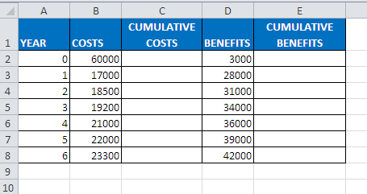
Task:
i. Copy the above table in Excel
ii. Use formulae to calculate the accumulative costs and benefits
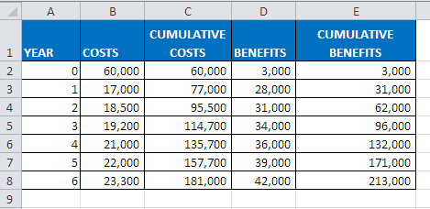

Year 4

0 1 2 3 4 5

60,000 77,000 95,500 114,700 135,700 157,700

iii. By inspecting the table, determine when the cumulative benefits exceed the cumulative costs:
Answer: At the end of year 4, the cumulative costs (135,700) are slightly larger than the cumulative benefits (132,000). During year 5, the cumulative benefits (171,000) far exceed the cumulative costs of 157,700. Therefore, at some point in time during Year 5, the accumulated costs and benefits are equal, establishing the payback period.
iv. Determine the payback period graphical:
Check out the graph below:
It looks like 4.2 years? What is 0.2 of a year? You agree it is about 2½ months?
Payback period is 4 years, 2½ months

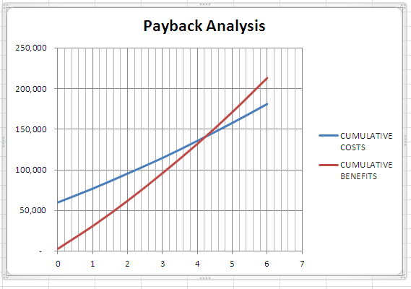
v. Use Excel and calculate the Return on Investment (ROI):
ROI is a percentage rate that measures profitability by comparing the total net benefits (the return) received from a project to the total coats (the investment) of the project.
$$ROI= \frac{Total Benefits-Total Costs}{Total Costs}$$
From Excel, ROI = 18%

Homework 3
Consider the following cost-benefit table:
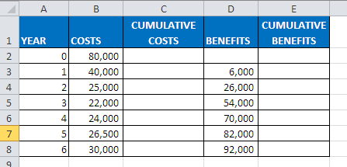
i. Use Excel and calculate the cumulative costs and benefits
ii. Estimate the payback period from the table
iii. Determine the payback period graphical
iv. Determine the ROI, in cell B10
Summarizing ALL of the above in ONE Excel sheet!
Consider the following project, consisting of yearly benefits, development costs, as well as yearly on-going costs:
 | Year 0 | Year 1 | Year 2 | Year 3 | Year 4 | Year 5 | TOTAL
Value of Benefits |  | 889000 | 1139000 | 1514000 | 2077000 | 2927000
Development Costs | -1336000
On-going Costs |  | -241000 | -241000 | -241000 | -241000 | -241000
To analyse this we need to determine the PV’s and the NPV’s. We will do it, but we also introduce the Cumulative NPV. You will realize now the advantages! Assume a discount rate of 10%, giving the following discount factors:

Year | Discount Factor
1 | 0.9091
2 | 0.8264
3 | 0.7513
4 | 0.6830
5 | 0.6209

Create the following spreadsheet:
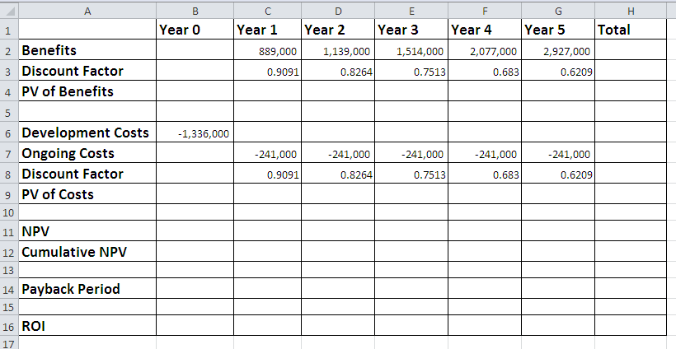
i. Calculate the PV of benefits, and their TOTAL: cell H4
ii. Calculate the PV of costs, and their TOTAL: cell H9
iii. Calculate the yearly NPV
iv. Calculate the Cumulative NPV. What is the meaning of the value in cell G12?
v. Payback period/breakeven point: the year the running accumulated NPV turns positive, is the year in which payback occurs. Here we also introduce ‘Interpolation’.
vi. ROI? Why don’t you try it!
Hint: Do the calculations step by step! The only extra work is to determine the Discount Factors.
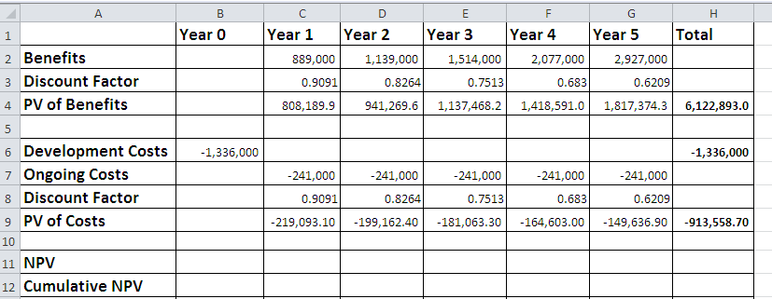
At this stage you can determine the NPV of the project! How much?

Complete the rest of the sheet:
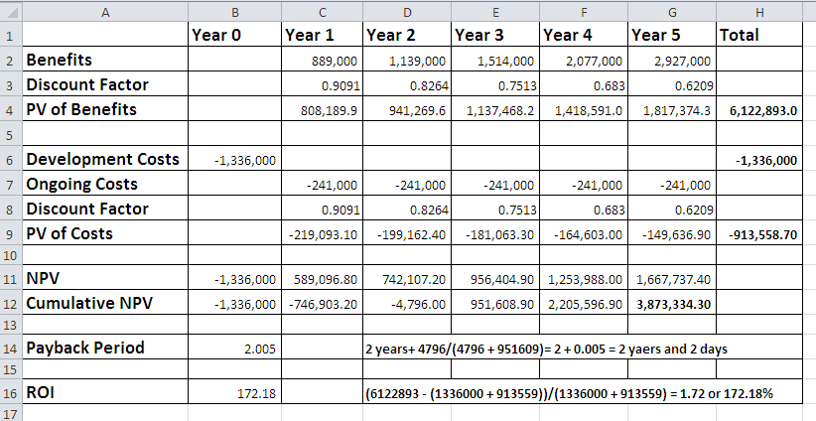
If you interested you can Google ‘Linear Interpolation’, to shed light on the calculation of ‘Payback Period’!
Homework 4: Develop a NPV spreadsheet, similar to the one above, but at a discount rate of 8%.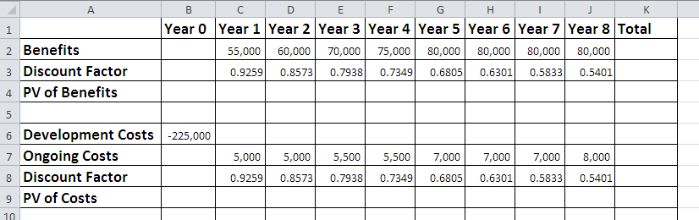
Draw a column chart, using B1:G1 against B12:G12, confirming the payback period. Marks will be allocated for title, and labels to axes.
Adding a data series to an existing chart
Sometimes we will have already created a graph and then decide that we also want to plot tha graph of another function over the same range of x-values.
Consider the function f(x) = x³/12, in the range -4 to +4: (use Excel to calculate column B, and draw a graph!)
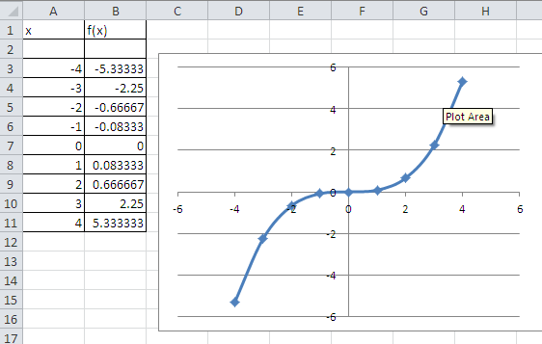
Next we want to include the graph of the inverse function by reversing the roles of the x- and y-values:

x | f(x) | x | f⁻¹(x)
-4 | -5.3333
-3 | -2.250
i.

ii. Select the chart of f(x)
iii. In the Data group on the Chart Tools design tab, click the Select Data button
iv. Select the ranges for the series values
v. Click OK
vi. Fine tuning will be done in class
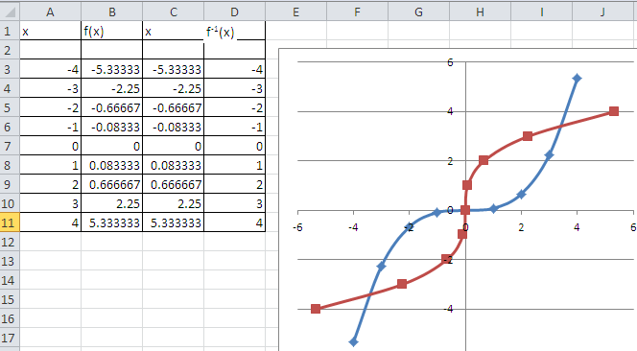

Appendix 2:
Project Management
Class Exercise: Let’s build a house! (House Project)

Task ID | Description of Task | Duration | Precedence
 | House Project
 | Site Preparation
1. | Clear site | 2 days | none
2. | Fencing | 1 week
3. | Material store | 2 days
 | Floors
4. | Dig foundations | 3 weeks
5 | Cast foundations | 1 day
6. | Floor slabs | 1 day
 | Erecting walls
7. | Build walls | 4 weeks
8. | Build roof | 3 weeks
9. | Windows | 1 week
10. | Plaster walls | 3 week
11. | Ceiling | 1 week
12. | Paint | 3 weeks
 | Site finale
13. | Landscaping | 1 week
14. | Paving | 1 week

- Complete the ‘Precedence’-task column.
- Represent the above in a Gant Chart
- Add a task ‘before landscaping’: uMhlathuze Borough to connect electricity, water connections and sewage connections. Give a week for each task
- Add a wait period of 1 day between ‘Floor Slabs’ and ‘Build Walls’
- Add the following Resources on the Resource Sheet:

RESOURCE | GROUP | STD RATE | OVR TIME RATE | MAX UNITS | CODE
Walls & Paving | Paving | R85.00 | R96.89 | 6 | Co005
Glass Calore Ltd | Glass Works | R35.00 | R48.95 | 10 | Co006
ABC Garden Services | Garden | R25.00 | R35.00 | 5 | Co008
Waldo's Construction | Construction | R55.00 | R65.00 | 45 | Co0010
Prominent Paints | Paint | R40.00 | R56.00 | 15 | Co0012

Questions:
- How long will it take to complete the house?

Assignment: Creating an IS, the following tasks were identified:

TASK | DESCRIPTION | DURATION  (DAYS) | PREDECESSOR  TASK
1 | Develop Plan | 1
2 | Assign Tasks | 4 | 1
3 | Obtain Hardware | 17 | 1
4 | Programming | 70 | 2
5 | Install Hardware | 10 | 3
6 | Program Test | 30 | 4
7 | Write User Manual | 25 | 5
8 | Convert Files | 20 | 5
9 | System Test | 35 | 6
10 | User Training | 20 | 7, 8
11 | User test | 25 | 9, 10

Task:
- Identify milestones
- Use the above information and create a WBS (sequential time line) using MS Project. (Gantt Chart)
- Create and add at least four resources of your choice.
- Convert the Gantt Chart into a PERT chart.

