University of Zululand
Website: http://www.unizulu.ac.za

Private Bag X1001
3886 KwaDlangezwa

Faculty of Commerce
Administration & Law
Department of Accounting and Auditing

Module Title | System Analysis
Module Code | CMIS301/CMIS321
Programme in which the module is offered | National Higher Degree: B.Com (Management Information Systems).
Year of offering | 2017
SAQA Credits | 15
NQF level | 7
Name of Lecturer / Lecturers | Mr BF Nel

“My cat is object-oriented. After all, a cat exhibits characteristic behavior, responds to messages, is heir to a long tradition of inherited responses, and manages its own quite independent internal state”.

TABLE OF CONTENTS
Page

- INTRODUCTION 3
- MODULE PURPOSE/OUTCOMES 4
- STUDY METHODS 4
- ASSESSMENT CRITERIA AND INSTRUMENTS 5
- TOPICS WITH SCHEDULING 6
- PRESCRIBED READINGS, AND ADDITIONAL (RECOMMENDED) READINGS 7
- GENERAL: ATTENDANCE, CONSULTATION AND RULES 7
- ADDENDUM: INTRODUCTION TO O-O CONCEPTS, AN EXERCISE 8

Introduction to Systems Analysis: CMIS301/321
Overview:

Software Development, System Analysis and Design
Computers are everywhere today, and microchips impact every part of our lives. We live in a world not only of ubiquitous computing but of pervasive communication and connectivity. A large part of our everyday lives depends on computer chips, connection links, databases, and application software.
Application software or computer software and the above mentioned technologies are part of a bigger picture, the Information System. They all ‘enable’ the information system! This will be our focal point, to design an Information System! How to arrive at an Information System, are summarized in the following four points:
- System Analysis: those activities that enable a person to understand and specify WHAT the new system should accomplish.
- System Design: those activities that enable a person to describe in detail the system that solves the need. The system design describes the HOW.
Centre to the course is the Systems Development Life Cycle or SDLC:
- SDLC consisting of six core processes:
- Identify the problem or need and obtain approval to proceed
- Plan and monitor the project – what, how and who does it
- Discover and understand the details of the problem or need
- Design the system components
- Build, test, and integrate system components
- Complete the system tests and deploy the solution.
- The focus of the development process is iteration, and the Agile Development process.
The Case Study Ridgeline Mountain Outfitters, or RMO, will be used as an example developing the above ideas.
In the second semester, CMIS302/322, the focus will shift to Project Management, Advanced Design and Deployment Concepts. If you did CMIS301, it is worth considering the 2nd semester course!
COURSE OUTCOMES:
From an instructional approach, the objectives are
- To teach the essential principles of system development
- To explain the new methodologies and techniques
- To use a tool to model/document the above specifications, i.e. requirements.
- Define a solution
- To encourage team work to build a solution
The course will consist of the following topics:
- Introducing system development
- Identify analysis tasks
- Designing a system

Important is mastering the following skills:
- Soft skills: Interviewing and interacting with users.
- Hard skills: technical and ‘to detail’ the specifications and designing solutions, usually consisting of creating models that capture specifications or define solutions
- Problem Solving: this is the essence of the course and will be discussed as the course unfolds.

STUDY METHOD/APPROACH:
- We will run the course in true OBE fashion, meaning ‘student-centred learning’. The old saying is still true:
“You READ and you forget, you SEE and you remember, you DO and you UNDERSTAND”.
The implication is that we will expect from you to work most of the times on your own, realizing your own potential. Therefore: Attend all your lectures and at the same time work through the study material as indicated in the ‘Weekly Plan’ schedule below. The outcomes spell out what is expected from you; always assess yourself in terms of these outcomes.
- Theory: Make sure you understand the key terms after each chapter. Do the Review Questions. Problems and exercises will be assigned as Homework. These will be done in groups, consisting of two people. It is your responsibility to inform me who make-up your team of two people! Otherwise, it will look as if you were copying the work, and it will nullify your attempt.
- Practical/Documentation: This will be assigned as we progress through the course work, using UML from MS Visio.

ASSESSMENT PROCEDURES AND CRITERIA:
Tutorials and home work must be done BUT no mark will be allocated towards them. Your attempt will be noted and can play a role in assigning marks for the DP and the Final Mark. I appreciate hard work, and will allocate it when deserving. I follow an OPEN discussion with students on these issues. The OUTCOME is very simple: you must master the work, knowing the prescribed book from cover to cover!
Formative assessments |  | Contr. to DP
Theory Tests (written) | 25% | √
Practical Test (Hands-On/ MS  Visio) | 25% | √
SUMMATIVE ASSESSMENT
Theory (Practical/Hands-On) | 50%
Total | 100%

A thorough discussion will be done in class before the assessment, so that there is no confusion!
ASSESSMENTS:
Theory Test: Written, Closed Book test on all theoretical concepts of System Analysis
Practical Tests: OPEN BOOK
- Test 1:
  - System Requirements
  - Use Case Descriptions
  - Activity Diagrams
- Test 2:
  - Domain Modelling
  - System sequence diagram
  - State Machine Diagram

Test dates as well as the outcomes, will be decided in class. If you are absent for any of these tests, satisfactorily and relevant documentation must be submitted to the lecturer within a week of the test date.
The examination contributes 50% to the Final Mark of the course.
- A learner will NOT BE ADMITTED to write the final examination unless a course mark (DP) of 40% has been obtained. The DP mark is made up of the above mentioned tests.
- The exam paper will last for at least 5 hours, with quite a focus on UML.

DUE DATES OF ASSIGNMENTS:
Ensure that all practicals, assignments are submitted on time, accordance with due dates. Should you not submit by the required date, a mark of ZERO will be awarded.

MORE ON SPECIFIC OUTCOMES, ASSESSMNET CRITERIA and ASSESSMENT INSTRUMENTS:
All outcomes are explained in the beginning of each chapter! I will not repeat them here, and the way you respond to the outcomes, are actually the criteria! The instruments can be or a combination of:
- Multiple Choice Questions
- Paragraph to Page/s length answers
- Applying MS Visio

WEEK BY WEEK PLAN:
Week | Topics | Chapter  Readings
1, 2 | Investigating Systems Requirements | Chapter 2
3, 4 | Use Cases | Chapter 3
5 | Test 1
6, 7 | Domain Modelling | Chapter 4
8, 9 | Extending the Requirements Models | Chapter 5
10 | Test 2
11 | Theory Test
12 | Revision/Preparation for Examination

NOTE FROM THE LECTURER:
I hope that you will find the module interesting and that it will exceed your expectations. It will be a bumpy ride at times, but you will enjoy it: your attitude will set your latitude! Good luck!

TEXTBOOK:
Satzinger, Jackson, Burd, Introduction to System Analysis and Design: An Agile, Iterative Approach, 6th edition, Course Technology, 2012
RECOMMENDED BOOKS:

- Requirements Analysis and System Design, by LA Maciaszek, 3rd Ed. 2007.
(ISBN 9780321440365)
- Use Case Driven Object Modelling with UML Theory and Practise, by D Rosenberg and
M Stephens, 2007 (ISBN 9781590597743)
- Applying UML and Patterns, An introduction to O-O Analysis and Design and Iterative Development, C Larman, 3rd Ed. 2005 (ISBN 0131489062)
- UML 2 and the Unified Process, by J Arlow & I Neustadt, 2nd Edition (ISBN 0321321278)
- Object-Oriented Analysis and Design with UML, by RV Stumpf and LC Teague, 2005 (ISBN 131434063)
- Understanding Object-Oriented Programming with Java, by T Budd (ISBN 020161273739)
- Introduction to Object-Oriented Analysis and Design, with UML and UP, by SR Schach(ISBN 0071215107)

The beauty of this is that ALL the above books are in our UZ Library…..enjoy the reading!!

CONSULTATION TIMES:
Make an effort to make an appointment during class, or use e-mail, but usually and it works: WhatsUp!! My cell: ...will be given in class! Time: 8h00 – 21h00, every day.
ATTENDANCE:
It is compulsory for students to attend classes.
RULES OF THE LAB:
Read the notices at the entrance of the laboratory. This is in the hand of the lab management, and there is no way that I can influence them, besides, you are senior students and must set an example to the juniors!

In true architectural fashion, one can say, ‘you are the architect of your own future’!
******************** Best of Luck! Enjoy!!**********************

Class Exercise: OO Principles
History (Really ….history. See bibliography page 13. But I found they explain OO concepts very well!)
TSD or traditional systems development paradigm analyzes a system to identify the functions it must perform. Functional decomposition is the process of identifying the major activities of a system, and then breaking it into composite steps:
- Process duty payments
  - Verify shipment receipt
  - Determine shipment product category
  - Calculate import duty etc.
Emphasizing the processes or functions that a system performs, functional decomposition is the underlying framework. This paradigm is embedded in Yourdon’s [1979] and deMacro’s [1979] Structured System’s Analysis and Design (SSA&D) and Martin’s [1990] Information Engineering (IE).
OS&BA or object structure and behavior analysis, a system is decomposed into objects. This paradigm emphasizes the things that comprise the system and how these things act and interrelate. Next an object model is created, describing each class in terms of its attributes, methods, and relationships to other classes. This specification of object classes is the foundation of object-oriented systems development (OOSD) paradigm. Booch [1993], Coad and Yourdon [1990, 1991]. Martin and Odell [1992], Rumbaugh [1991], and Schlaer and Mellor [1989], among others, have proposed methods to guide systems development under this new paradigm.
These two paradigms adopt different perspectives to decompose a system. TSD focuses on WHAT a system does, that is the verbs that describe the system; OOSD focuses on what a system is made of, that is, on the nouns, that describe the system. Simply, TSD is concerned with functions performed on data; OOSD is concerned with objects performing the functions. They are similar in that both are concerned with software and data. TSD separates software and data components, whereas OOSD combines data and software into a single construct, an object.
Systems Development Catalysts ( System Project)
The impetus for a system development project comes from three catalysts:
- User demand
- Technology push and
- Strategic pull
User demand arises out of problems users have with the current system; system errors, system efficiency, system compatibility, or system enhancements.
Technology push describes how new technology can be a catalyst, because they can make possible new, more effective and efficient ways of doing business, and exploit new opportunities.
Strategic pull describes how an organization’s objective and strategies can “pull” an organization to support these strategies and help the organization stay competitive.
On the next page is a narrative, describing people, a dog and a veterinary. We will try to explain some object-oriented concepts, using this story!
Once upon a time there were two unhappy people, a dog and a ball. One person, Fred was very unhappy. The other person Cathy, was unemployed. Fred had heard that dog owners are seldom lonely, so Fred went to a pet shop and bought a dog, a male German Shepherd puppy that he named Fido. Cathy heard that vets are in high demand, so she earned a veterinary medicine degree from Tufts University and opened an animal clinic so that she would be happy and have a steady, well-paying job.
Fred, though no longer lonely, was still unhappy because he worried that his dog, Fido, was very bored. So Fred went back to the pet shop and bought a small red ball. Fred taught Fido how to retrieve the ball. Fred would throw the ball, and Fido would fetch it. Now that Fido had a ball to play with, he was no longer bored; in fact, Fido was very happy, and Fred was no longer worried; he was very happy.
One day, when Fred threw the ball, Fido swallowed it. Fido became very sick; Fred became very worried. Fred took Fido to Cathy’s animal clinic. Cathy treated Fido (you don’t want to know the details) and Fred paid Cathy. Fido was no longer sick. Fred, although no longer worried, was a little poorer; whereas Cathy was a little bit richer.
An object class (or a class) is a
- Set of people
- Places
- Things
- Or transactions
that share common attributes and perform common functions to help an organization reaches its goals.
Examples:
- People: employees, vendors, customers
- Places: warehouses, office, branches, shipping docks
- Things: products, office equipment, supplies
- Transaction: purchases, sales, returns, payments
From the narrative:
- People: dog-owner, vet, person
- Places: pet shop, clinic
- Things: Ball and……..dog
- Transaction: payment, treatment
OO: a class is an abstraction or model of a real concept.
Abstraction plays a major role in the design process in general, relates to describing the essential features of an object, its behavior, and its relationships with other objects, while ignoring aspects irrelevant to the current perspective or purpose.
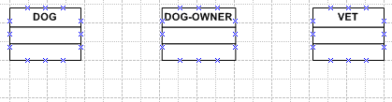
Object Instances and Inheritance
is a particular person, place, thing, or transaction. In other words an object instance is a member of an object class. Each object instance is described by specific values for the attributes of the class and can perform all the methods of the class.
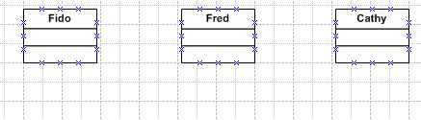
We need objects because they are the building blocks of almost any data or software component.
Inheritance: an object inherits the attributes and methods of its superclass, in addition to having all the attributes and methods of its subclass.
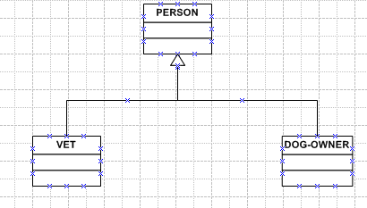
Inheritance is a property unique to the object-oriented paradigm. It allows the generic description of objects, so that subclasses “inherit” the properties of their parent class, but are specializations of it in some way. Object classes are arranged in hierarchies, with inheritance up the hierarchy.
Need to determine attributes:
OO theory continues by examining the kind of knowledge that is attached to each internal object. After recognizing the objects, the internal representation of the object must include a record of its properties. For example, we remember that a shirt’s color is blue and its size is large. In OO, COLOR and SIZE are referred to as attributes; BLUE and LARGE are attribute values. These values ultimately will determine the state of an object. Every object has its own set of attributes (and values) determine by the context of the problem domain: a student object in a ‘maintaining marks’ and in ‘account status’ will be different!
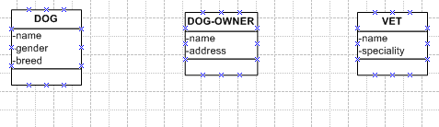
The next task is to identify verb phrases, and express it as a behavior:
- “What role does each class play? What are the responsibilities?”
- “Does any other object need to use the attributes?’

Entity Class Behavior Method
Vet treat animals giveTreatment
charge for treatment calculateAmount
Dog-Owner play with dog throwBall
pays for treatment makePayment
Dog wants to play fetchBall

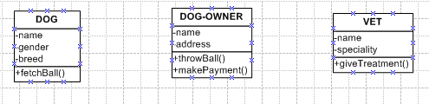
NOTE: What happens with the method/operation calculateAmount?
Key concepts of OO system behavior
Each object class controls its own data and can define methods
- To manipulate its own data for its own purposes and
- To report data to or to perform manipulations of its data for another object
Every class must perform the CRUD functions of creating, reading, updating, or deleting an instance of an object class. Methods that perform these CRUD functions are called implicit methods.
Private methods are performed for the object’s own benefit and are not known to any other object. An example can be where an ORDER class has attributes like subtotal, salesTax, and total. Using the method calculateTotal, an object can add the value of its subtotal to the attribute value of salesTax to determine total.
A service, or public method “services” the needs of other objects, and is “public” in the sense that other objects know about its existence. Public methods form the service interface of an object.
Visualize the picture below: it resembles an object. The data and private methods are hidden; only its public methods are exposed. And this exposure is limited to other objects, knowing that the methods exist; they do not know, nor need to know, how the method is performed.

This leads to the concept of encapsulation. Encapsulation refers to the integration of data with the processes/operations/functions executed on it. It also incorporates the concept of information hiding whereby the implementation details of an object are concealed. What encapsulation really means to the analyst or designer is that the kick-off point is determining the objects in an application, and defining them along with their attributes and processes that act on them/operations they perform.
Encapsulation provides two benefits. One is to protect each object’s data by allowing only the object itself to manipulate its data, thus preventing data corruption that can occur in traditional systems in which multiple programs access and manipulate data stored in a single file.
Secondly, encapsulation reduces the rippling effect so often see in conventional systems in which a change in the data structure necessitates a change in the programs that use it. In OO system, the “what” (data) and “how” (methods) of a class are only known to that class. Thus a single class can be changed without requiring changes to other classes.
The effect of encapsulation is that objects must have some way to communicate so that they can request services: messages. A message is a request from one object to another signaling the receiving object to perform one of the methods: (I used the syntax of T Budd)
<receiving object instance> .<method> <parameters>
The dot means the invocation of a method
The message selector-text following the dot- must match one of the methods defined in the class
Example: (Note: Usually Window specification work the ‘opposite’-way….you ok?)
fred.throwBall(25, 37)
This command instructs the dog-owner, fred, to throw the ball to co-ordinates 22 meters west and 15 meters north of some reference point.
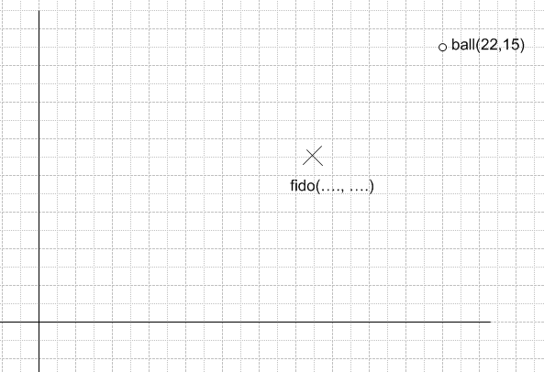
Task: Write an instruction for Fido to collect the ball, if Fido is at the point indicated with an X.
Maximum cohesion and minimum coupling are achieved by:
- Early encapsulation of objects and processes during analysis which automatically embeds cohesion in the application
- Communication via messages which automatically provides minimal coupling
Polymorphism
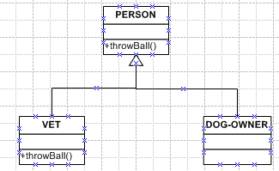
What is the difference between cathy.throwBall() and fred.throwBall()?
Fred exploits inheritance and uses all the attributes and methods of PERSON. In Cathy’s case, the same method appears in the super-class as well as the sub-class. In such a case the method in the sub-class overrides - or substitutes – the method in the super-class. Thus although the method throwBall is called by the same message, it will performed different functions depending on whether it is invoked as part of the VET class, or the DOG-OWNER class. That is the power of polymorphism: the same operation may be carried out in different ways that is using different methods by different classes.
Incremental prototyping
Systems development in OO also differs from that of the other methodologies. Even in the traditional life cycle, the distinction between systems design (broad design) and program design (detailed design/coding) can become blurred. In OO the boundary is even more indistinct, because the top-down analysis and bottom-up program development occur simultaneously or, at least, iteratively. With relation to the SDLC, OO approach ignores front-end activities, such as business analysis and feasibility analysis, assuming that they are performed prior to the use of OO methods. The three traditional phases of analysis, design, and implementation are all present, but the joints between them are seamless. The unifying factor is the prime role played by objects and their interrelationships. The OO methodology lends itself to an iterative, incremental protptyping life cycle. Modeling is also prominent in OO design, the basic architecture being assembled from models of the objects and the relationships between them.
Questions:
- Define “system”, and explain how an Information System conforms to this definition
- Explain the OO concepts of object class, object instance, and inheritance
- Describe the phases of the system life cycle
- Explain the systems approach to problem solving
- Define “system decomposition” and explain several ways of decomposing an Information System
- Describe the catalysts for systems development
- List and discuss the goals of system development
- Distinguish between a logical and a physical function
- Define the 5 functions of an Information System
- Explain the sociotechnical perspective of Information System
- Define and give examples of the 5 components of an Information System
- Explain how an object encapsulates the data and software components of an Information System
Bibliography:
- System Analysis and Design and the transition to Objects, SD Dewitz, 1996, McGraw-Hill
- An introduction to Object-Oriented Programming, T Budd, 1991, Addison-Wesley
- UML for the IT Business Analyst, H Podeswa, 2005, Thomson
- UML 2.0 in a nutshell, D Pilone, 2005, O’Reilly
- Advanced Systems Development iNF305-F, R Bosua, R de Villiers, 1996, UNISA

Roger King [Kim and Lochovsky 1989]

