Question 1 [63 Marks]

Your supervisor in the Finance department at Med Supply Online Warehouse has asked you to create a worksheet that will project the annual gross margin, expenses, total expenses, operating income, income taxes, and net income for the next six years based on a table of assumptions he has provided you with.
Prepare a worksheet as the one below, with each entry in a new cell:

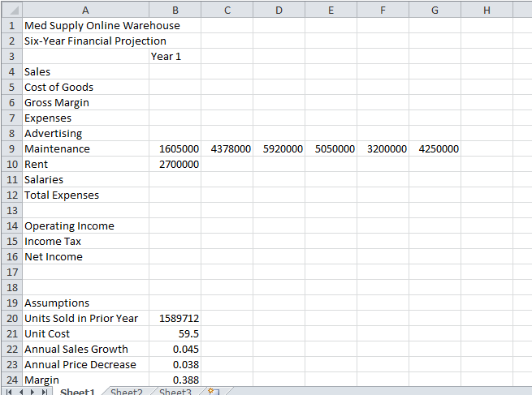

- Formatting (Each questoin counts 1 Mark) (11)
  - Apply the Civic theme to the workbook
  - Bold the entire Sheet1 worksheet
  - Format the worksheet title in cell A1 to 36-point Tahoma font.
  - Format the worksheet subtitle in cell A2 to 20-point Verdana font.
  - Enter the system date in cell G2 using the NOW function. Format the date using the 14-Mar-01 date format.
  - Format cell B3 as follows:
(a) increase the font size to 14;
(b) centre and italicize; and
(c) rotate the text to an angle of -45°.
Apply the same formatting to the range C3:G3.
  - Change the font in cells A7, A15, A17, and A19 to 14-point Verdana.
  - Apply the Thick Bottom Border to the ranges B3:G3 and B5:G5.
  - Use the Increase Indent button to increase the indent one level for the row titles in cell A5, the range A8:A11, and cell A15.

- Calculations (Each questoin counts 3 Marks) (36)
Be sure to use absolute references where appropriate in the formulae

  - In cell B4, enter the following formula: Year 1 Sales (cell B4) = Units Sold in Prior Year * (Unit Cost / (1 - Margin)) or =B23 * (B24 / (1 – B27))
  - In cell C4, enter the following formula: Year 2 Sales (cell C4) = Year 1 Sales * (1 + Annual Sales Growth) * (1 - Annual Price Decrease). Copy cell C4 to the range D4:G4.
  - In cell B5, enter the following formula: Year 1 Cost of Goods (cell B5) = Year 1 Sales * (1 – Margin) or =B4 * (1 - $B$27). Copy cell B5 to the range C5:G5.
  - In cell B6, enter the following formula: Gross Margin (cell B6) = Year 1 Sales - Year 1 Cost of Goods. Copy cell B6 to the range C6:G6.
  - In cell B8, enter the following formula: Year 1 Advertising (cell B8) = 500 + 8% * Year 1 Sales. Copy cell B8 to the range C8:G8.
  - In cell C10, enter the following formula: Year 2 Rent (cell C10) = Year 1 Rent * (1+12%). Copy cell C10 to the range D10:G10.
  - In cell B11, enter the following formula: Year 1 Salaries (cell B11) = 17% * Year 1 Sales. Copy cell B11 to the range C11:G11.
  - In cell B12, enter a function to calculate the total expenses. Copy cell B12 to the range C12:G12.
  - In cell B14, enter the following formula: Year 1 Operating Income (cell B14) = Year 1 Gross Margin - Year 1 Total Expenses. Copy cell B14 to the range C14:G14.
  - In cell B15, make use of the IF function: Year 1 Income Taxes (cell B15) =
If Year 1 Operating Income is less than 0,
then Year 1 Income Taxes equal 0;
otherwise Year 1 Income Taxes equal 45% * Year 1 Operating Income

Copy cell B15 to the range C15:G15.
  - In cell B16, enter the following formula: Year 1 Net Income (cell B16) = Year 1 Operating Income - Year 1 Income Taxes. Copy cell B16 to the range C16:G16.
  - In cell H4, insert a Sparkline Column chart for cell range B4:G4. Repeat this step to insert Sparkline Column charts in the cells H5:H6, H8:H12, and H14:H16

3. Formatting (2 Marks for each correct formatting; except 3.4: 5 Marks) (9)
3.1. Assign the Currency style with a NO Rand sign to the numbers in B4:G11; B14:G15.
3.2. Assign the Accounting style to the numbers B12:G12; and B16:G16
3.4. Use conditional formatting to change the formatting to red font in any cell in the range B16:G16 containing values greater than R 7 500 000.

4. Charting (Only 1 Mark will be assigned to each correct answer) (7)
4.1. Use the nonadjacent ranges B3:G3 and B16:G16 to create a Clustered Cylinder chart.
4.2. Select the legend on the right side of the chart and delete it.
4.3. Add the chart title Six-Year Net Income Projection.
4.4. Change the colour of the cylinders to the theme colour Red, Accent 1, Darker 25%.
4.5. Change the colour of the wall to the theme colour Ice Blue, Background 2.
4.6. Change the floor fill colour to the theme colour Black, Text 1
4.7. Rename the Sheet1 sheet tab as Six-Year Financial Projection.

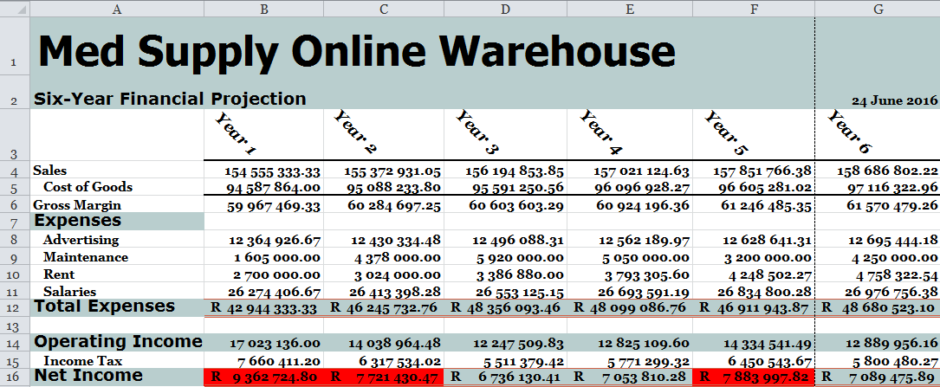
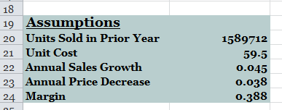

End Of Paper

